בס”ד

Murex Trunculus -
The Rediscovery of Techeiles
or Just Another Fashion Fad

Rabbi Chaim Ozer Shulman

I. History & Background

A. Lost after חתימת הגמרא (perhaps 600’s CE)

גמרא מנחות מג. - מר ממשכי אייתי תכלתא בשני רב אחאי בדקוה כו’
“Mar from Mashki brought techeiles in the time of Rav Achai, and they tested it [and it was techeiles].” Rav Achai was from the latest Amoraim. In fact he was one of the Rabbanan Savurai and he passed away in 510CE (lived one generation after Ravina & Rav Ashi).

מדרש תנחומא פר’ שלח - ועכשיו אין לנו תכלת תכלת נגנז.
The Midrash Tanchuma (compiled 750 CE) says that we no longer have techeiles since techeiles was hidden.
So it’s assumed that teicheles and the chilazon that produces it was lost some time in the 600’s (perhaps 639 Arab conquest) about 1300 to 1400 years ago.

B. 1857 Murex discovery

French zoologist Henri de Lacaze discovers 3 dye producing snails in Mediterranean - Murex brandaris, Murex trunculus and Thais haemastoma, as the source for the purple dye used by royalty (royal purple) used in ancient times.

C. 1888 Radziner Rebbi identifies cuttlefish as chilazon

Rav Gershon Henoch Leiner, Radziner Rebbi, felt discovery of techeiles was precursor to coming of mashiach. Identifies cuttlefish (Sepia officinalis - similar to a squid) as chilazon.

D. 1913 Rav Herzog Disproves Radziner Techeiles

Rav Herzog (later first chief rabbi of Israel) in doctoral dissertation proves that cuttlefish does not create blue dye, but rather the chemical additives themselves produce a blue dye and the cuttlefish can be replaced with any organic entity. Thus cuttlefish is not an essential component of blue dye!

E. 1913 Rav Herzog Identifies Murex trunculus as a likely candidate as chilazon, but it’s purple

Rav Herzog identifies the Murex trunculus as a likely candidate for the chilazon, but the dye produced is purple rather than blue.

מנחות דף מג: - תניא, היה ר’ מאיר אומר: מה נשתנה תכלת מכל מיני צבעונין? מפני שהתכלת דומה לים וים דומה לרקיע ורקיע לכסא הכבוד.

It is unlikely that techeiles is purple since techeiles is compare to the sea (contrary to Prof. Irving Ziderman).

F. Rav Herzog suggests that Janthina snail may be chilazon but secretion turns brown

Rav Herzog identifies Janthina snail as likely candidate for chilazon. But there doesn’t seem to be a way to produce blue dye from it. Janthina does secrete blue liquid, but it turns brown after a few minutes. (See claim of Dr. Kaplan in www.realtekhelet.com that in 2002 he was able to produce blue dye from it, though he does not present any details or scientific verification on his website.)

G. 1980 - Professor Elsner discovers that exposure to sunlight causes Murex trunculus reduced dye to produce blue dye (dibromoindigo turns to indigo)

Professor Otto Elsner and Prof. Ehud Spanier discover that when trunculus dye is in reduced dehydrated state, exposure to ultra-violet light of sun will (unbind the bromide atoms from the indigo molecule) and transform the blue-purple dibromoindigo to pure blue indigo.

H. 1993 - Amutat Ptil Tekhelet founded to produce tekhelet strings

Based on work of Rabbi Eliyahu Tavger in 1980s and 1990s, Ari Greenspan, Baruch Sterman and Joel Guberman form Amutat P’til Tekhelet & begin producing and selling blue techeiles from Murex trunculus.

II. Proofs for Murex Trunculus Being Chilazon

A. Archeological evidence shows tremendous amounts of Murex shells in coast of Northern Israel and Lebanon, in area identified in Maseches Shabbos as place chilazon fisherman are

שבת דף כו. - “ומדלת הארץ השאיר נבוזראדן רב טבחים לכרמים וליוגבים” (ירמיה’ 16 52). כורמים - תני ר’ יוסף אלו מלקטי אפרסמון מעין גדי ועד רמתא. יוגבים - אלו ציידי חלזון מסולמות של צור ועד חיפה
Nevuzadran chief executioner left poorest of land to the kormim and the yogvim. The kormim are the gatherers of balsam from Ein Gedi to Ramasa. Yogvim are the ones who catch chilazon [on the Mediterranean] from the height of Tyre until Haifa.

Archeological digs show much evidence of the dying industry in Northern coast of Israel and southern Lebanon. Phoenicia was the center of the dye industry in the ancient world.

Archeological digs in the late 19th Century show enormous numbers of broken Murex shells (Murex trunculus, Murex brandaris and Thais haemastoma) in Sidon (Lebanon) & Tyre (Lebanon; south of Sidon), and the shells are cut open by the hypobrachial gland where the dye was extracted.

The gemara in Shabbos identifies the area in northern Israel & southern Lebanon from Sulamos Tzur until Chaifa as the place where techeiles dye was obtained where chilazon was fished. It is very possible that since Murex in produced in Northern Israel / Lebanon coast and chilzon is produced in Northern Israel/Lebanon that Murex is chilazon.

This proof does not support Janthina or cuttlefish.

Dr. Zvi Koren found in Masada a fabric with purple dye, which tested as being from Murex trunculus, according to paper given Feb. 28, 2011. See NY Times Feb. 28, 2011. [Perhaps that dye was prepared without sunlight.]

B. Chilazon is identified as having a shell in Shir Hashirim Raba and in Maseches Shabbos

שיר השירים רבה (11:4) - שמלתך לא בלתה מעליך כו’ ולא היו גדלים? אמר ליה צא ולמד מן החלזון שכל זמן שהוא גדל נרתיקו גדל עמו
Go and learn from the Jews in the desert from chilazon that all the time it grows it’s shell grows with it.

שבת דף עה. - הצד חלזון והפוצעו כו’ ר’ יהודה אומר חייב שתים.
One who traps chilazon and “breaks it open” on shabbos violates hunting, or according to Rabi Yehuda two transgressions (for hunting (צידה) and threshing (דישה)).

So we see that chilazon is not a cuttlefish, but rather a snail with a shell that must be broken open, like the Murex snail (or possibly the Janthina snail).

C. Zevulun is promised Sefunei Timunei Chol - Murex Snail Burrows in Sand

גמרא מגילה ו. - אמר זבולון כו’ לאחיי נתת להם שדות וכרמים ולי נתת הרים וגבעות לאחיי נתת להם ארצות ולי נתת ימים ונהרות. אמר לו כולן צריכין לך על ידי חלזון שנאמר (דברים ל”ג) [עמים הר יקראו כו’ כי שפע ימים יינקו] ושפוני טמוני חול.

Zevulun was given chilazon as stated in Vizos Habracha: “By the riches of the sea they will be nourished and by treasures concealed in sand.”

We see that the chilazon is buried in the sand. Murex burrows into sand and sediment on the sea floor.

This is not true of the cuttlefish or the Janthina snail (Janthina lives by floating on water and will drown underwater, so it can’t live burrowed in the sand according to Twerski).

D. Etymology - In Farsi Chilazon is a Snail; Raavia quotes Yerushalmi that Chilazon is Propherin which is Greek word for Murex

As pointed out by the Twerski article, in Farsi (Persian language) and Assyrian “chilazon” means a snail. Which supports snail (Murex or Janthina) theories, but not cuttlefish.

Also, the Raavia quotes a Yerushalmi
ראבי”ה ברכות דף ט. סי’ כ”ה - וגרסינן בירושלמי בין תכלת לכרתי בין פרופירין לבין פריפירין
Identifies techeiles with the Greek word for Murex. (Not Janthina or cuttlefish.)

E. Gemara Shabbos says chilazon must be alive to produce good dye - consistent with mucus of Murex that deteriorates very quickly after death

גמ’ שבת דף עה. ולחייב נמי משום נטילת נשמה? כו’ מתעסק הוא אצל נטילת נשמה. והא מודה ר’ שמעון בפסיק רישא ולא ימות? שאני הכא דכמה דאית ביה נשמה טפי ניחא ליה כי היכי דליציל ציבעיה. (רש”י שדם החי טוב מדם המת.)

Regarding that if trap chilazon transgress for trapping and for breaking, let one also transgress killing? Answer is that one is preoccupied regarding taking a life and is not mechaven. But Rebi Shimon agrees one is chayav if it is an inevitable consequence? It’s Lo Nicha Lei - one doesn’t want that consequence (and like not mechaven according to Aruch or Melacha Sheein Tzricha Ligufa according to Tosafos). Reason because the longer it stays alive the more pleased he is so that the dye will be clearer (as Rashi says that the dye of the life chilazon is better than the dye of the dead chilazon).

This is consistent with Murex because the mucus of Murex in order for the color changing process to develop, a specific enzyme purporase must be present which quickly deteriorates soon after death, and then the mucus won’t develop into the dye (Twerski).

This is not true of Janthina or cuttlefish.

F. If not Murex, generally should have warned against it like קלא אילן

Another support that Murex is chilazon, is that if it is another unidentified source, e.g. another snail, why would the Gemara not specifically warn to exclude Murex like it warned to exclude the indigo plant dye.

III. Problems With Murex Theory & Solutions

A. Chilazon Braisa

מנחות דף מד. ת”ר: חלזון זהו - גופו דומה לים, וברייתו דומה לדג, ועולה אחד לשבעים שנה, ובדמו צובעין תכלת, לפיכך דמיו יקרים.
The chilazon, its body is similar to the sea, its form is like a fish and it comes up every 70 years, and its blood is used for techeiles, therefore it is very expensive.

B. Problem 1 with Braisa - גופו דומה לים
Solution - Sea fouling gives it appearance like the seabed

Several problems raised based on this Braisa. First, as Rav Herzog asks, the body of the Murex snail does not appear to be blue. It’s more white or grey.

The answer given by Baruch Sterman and others is that the Murex snail in it’s natural habitat is covered with sea fouling giving it a blue hue, and making it look like the seabed. So דומה לים means it looks like the seabed when diving for it, so it is very hard to find. (Rav Herzog’s Murex was probably cleaned.)

Rav Yehuda Rok says this may be a reason why it is expensive.

C. Problem 2 with Braisa - ברייתו דומה לדג
Solution - Its creation is like fish in that it spawns eggs like fish

Dr. Mendel Singer asks that how is it ברייתו דומה לדג which Rashi explains to mean תבנית דיוקנו its form (and Rabeinu Gershom says בריאת צורתו). How is its form like a fish?

It may just mean it is a snail which has certain characteristics like a fish, even though a snail is not a fish in the common usage of the word fish. (In the English language though, snail is defined as a type of fish.)

It may also mean, as Baruch Sterman suggests, that בריאתו means its creation. Its creation is like fish because the Murex spawns, depositing its eggs like a fish.

D. Biggest problem with Braisa - עולה אחד לשבעים שנה
Possible solution - Comes up on the beach very infrequently

The biggest problem posed from the Chilazon Braisa cited above is it’s final statement
ועולה אחד לשבעים שנה, ובדמו צובעין תכלת, לפיכך דמיו יקרים
Murex does not have a cycle? This issue was also raised by Rav Herzog.
Rav Herzog says “Science knows nothing of such a septuagenarian ‘appearance’ of any of the denizens of the sea.”

The Rambam doesn’t quote this criterion.

Possible solutions - Maybe the Murex becomes less available or accessible due to overfishing.

The Chida describes the עולה אחד לשבעים שנה to mean it miraculously comes onto the beach once every 70 years.

Solution given by Baruch Sterman and others - Maybe what it means is that it rarely comes ashore and becomes readily available in abundance except very rarely. Other times you have to dive for it. 70 years is a term to mean very rarely.

E. Problem with chemical tests in gemara if Murex dye is chemically identical to Kala Ilan (indigo)
Perhaps test detects impurities in plant-derived indigo - Not satisfactory answer

One of the biggest problems with the Murex theory is that the Gemara in Menachos gives a chemical test to tell the difference between Kala Ilan, which the Aruch and others assume is plant-produced Indigo, and real techeiles.

מנחות דף מב.-מג. - ת”ר תכלת אין לה בדיקה ואין נקחית אלא מן המומחה כו’ ותכלת אין לה בדיקה? והא רב יצחק בריה דרב יהודה בדיק ליה מייתי מגביא גילא ומיא דשבלילתא ומימי רגלים בן ארבעים יום ותרי לה בגווייהו מאורתא ועד לצפרא איפרד חזותיה פסולה לא איפרד חזותיה כשרה. ור’ אדא קמיה דרבא משמיה דרב עוירא אמר מייתי חמירא ארכסא דשערי ואפיא לה בגוויה אישתנאי למעליותא כשרה לגריעותא פסולה כו’. מאי אין לה בדיקה נמי דקאמר אטעימה. כו’ היכא דבדקנא בדרב יצחק בריה דרב יהודה לא איפרד חזותא כשרה איפרד חזותיה בדקינן לה בדרב אדא בחמירא ארכסא אשתני למעליותא כשרה לגריעותא פסולה.
Menachos 43. - There are 2 tests. You put in liquid alum, juice of fenugreek, and 40 day old urine and soak the blue wool in it overnight. If it doesn’t fade it is kosher. If it fades then you use a second test of hard barley and yeast. If the color changes for the better than it’s techeiles, but if it changes for the worse it’s kala ilan.

The question is that according to the Amutat P’til Tekhelet, the Murex trunculus dye in its reduced state is exposed to the sun’s ultraviolet rays which unbinds the bromide atoms from the indigo molecule, leaving the remaining chemical dye, indigo, which is chemically identical to plant-derived indigo (kala ilan).

So indigo dye from Murex is the same chemically as indigo dye from plant. If the indigo is chemically identical, how would a chemical test cause one dye to fade and one to not fade? This is asked by Dr. Singer and others.

Notes on Gemara - Some scientists discard the Gemara’s tests, noting that the Amoraim were not chemists. That is not a very satisfactory answer.

Baruch Sterman notes that he did subject the Murex dye to the Gemara’s tests and it did not fade. Thus, that should satisfy the Gemara. Again, it’s not entirely satisfactory, since we are left without an understanding why kala ilan would fade.

Answer - There are several other answers given. First, it is possible that the chemical tests might be used to detect impurities that might be found in the plant-derived indigo but not in snail-derived indigo.

(Twerski quotes Sterman that the snail may have been reduced chemically using lead and tin pots with sulfuric reducing agents found in the glands of snails. Plant-derived indigo has no proteins or sulfur compounds. Until recently, indigo was reduced by fermentation, using bran, madder and sugars to cultivate the bacteria necessary to reduce the dye. These differences may have had something to do either with the way that the dye adhered to the wool, or perhaps to some extraneous chemicals found in the dyed wool (maybe in the snail tekhelet, or just as possibly in the plant indigo).)

Turning question into a proof? Interestingly, the Amutat P’til Tekhelet uses the question to actually buttress the claim that Murex trunculus is the chilazon. They point to a Gemara in Bava Metzia.

בבא מציעא סא: - אמר רבא: למה לי דכתב רחמנא יציאת מצרים ברבית, יציאת מצרים גבי ציצית, יציאת מצרים במשקלות? אמר הקדוש ברוך הוא: אני הוא שהבחנתי במצרים בין טפה של בכור לטפה שאינה של בכור - אני הוא שעתיד ליפרע ממי שתולה מעותיו בנכרי ומלוה אותם לישראל ברבית, וממי שטומן משקלותיו במלח, וממי שתולה קלא אילן בבגדו ואומר תכלת הוא.
I, Hashem who could tell the difference between a first born and non-first born in Egypt will take retribution from someone who puts Kala Ilan in his garment and says it is techeiles.

The Amutat P’til Tekhelet say that the fact that it is compared to Hashem’s ability to tell the difference between a first-born would support the view that techeiles is indigo from Murex, which is chemically identical to plant-derived indigo and therefore only Hashem can tell the difference.

This still doesn’t answer the Gemara in Menachos though, and at best makes it into a machlokes.

F. How same chemical could be valid if snail-derived and invalid if plant-derived

Another issue with the Murex theory is how can the same identical chemical be valid techeiles if made from a Murex snail and not be valid if made from the indigo plant? These produce the identical chemical molecule?

The answer is that we find the Torah is concerned with not just the result but also the process, e.g., with Shechitah, etc.

IV. Is Mesorah Needed to Determine Techeiles? Should You Wear Murex Dyed Tsitsis if Just aספק ?

A. Do you need a Mesorah? Differing Views of Beis Halevi’s Objection

1. Negative Mesorah. The Radziner quotes an objection made by the Bais Haleivi to the cuttlefish theory. The cuttlefish was in existence and common throughout the ages. Yet the Rishonim and Achronim did not wear it as techeiles. This should be like a mesorah that the cuttlefish is NOT the chilazon.

Rav Elyashiv in קובץ תשובות סי’ ב’ wonders if this argument of a negative mesorah might apply to the Murex as well.

It appears that this argument should not apply to Murex because the Murex snail and the complex method of obtaining a blue dye from it was not readily available. So there is no negative mesorah that it is not the Murex.

2. Rav Solovietchik’s version of Beis Haleivi’s objection - need positive mesorah

Rav Y.D. Soloveichik zt”l in שיעורים לזכר אבא מורי pg. 228 quotes the Beis Haleivi as having a more basic objection to the Radziner techeiles which would likely apply to the Murex techeiles as well. The Soloveichik quotes the Beis Haleivi that we cannot rely on scientific evidence for something like techeiles, where we rely on a tradition handed down generation to generation. You would need a mesorah to reinstitute techeiles.

This version of the Brisker objection would presumably apply not just to the Radziner techeiles but also to Murex.

The problem with this version is that there doesn’t seem to be a source for why you should need a mesorah.
No one says that Rashi or Rabeinu Tam tefilin would need a mesorah.

Also, why can’t you rely on scientific evidence, which is like an אומדנא דמוכח which as Rabbi Twerski points out is stronger than רוב?

B. What if just a ספק if Murex is techeiles? Should you wear the Murex tsitsis?

If you don’t accept the proofs for Murex trunculus as compelling beyond a doubt - and say it’s not an אומדנא דמוכח would you still say that since it is likely at least a ספק if it is techeiles, one should wear the Murex dyed tsitsis as a ספק דאורייתא לחומרא?

I would think you probably should. However, there are 3 possible reasons why not to use the Murex dyed tsitsis if it’s just a ספק.

1. מסורה argument would likely apply for just a ספק

It could be that even if you don’t accept the Rav’s version of an obligation to have a positive mesorah for techeiles, nevertheless to put on a new type of tsitsis every time a new scientist makes a discovery, for this we would say you need a mesorah.

2. Need color of beged - ממין הכנף according to one view of rishonim

Rav Elyashiv in קובץ תשובות סי’ ב’ brings another concern why you shouldn’t use the Murex dyed tsitsis if you don’t know if it is techeiles. He quotes the following Shulchan Aruch:

שולחן ערוך סי’ ט’ סעי’ ה’ - ויש אומרים שצריך לעשות הצצית מצבע הטלית והמדקדקין נוהגין כן.
רמב”ם פ”ב מהל’ צצית ה”ח - טלית שהוא כולו אדומה או ירוקה או משאר צבעונין עושה חוטי לבן שלה כעין צבעה אם ירוקה ירוקין אם אדומה אדומין.
רמ”א סי’ ט’ סעי’ ה’ - והאשכנזים אין נוהגין לעשות הציציות אלא לבנים אף בבגדים צבועים ואין לשנות (תרומת הדשן סי’ מ”ו)

According to the Rambam & Shulchan Aruch you need that the non-techeiles tsitsis should be the same color as the talis. Red beged red tsitsis, white beged white tsitsis.

This is based on a גמרא in מנחות דף מא:
מנחות דף מא: - טלית אין פוטר בה אלא מינה ועי”ש ברש”י ותוס’
A talis only a thread of its own kind satisfies the obligation.

Two reasons are given for this. Rashi and the Raavad say that you need the same color to be ממין הכנף, which is a דאורייתא. But Tosafos says that its only because זה קלי ואנוהו.

According to the Shulchan Aruch that you need the same color, according to view of rishonim that it’s a דאורייתא there may be a problem because you can’t say that it’s no worse than לבן because you need ממין הכנף . So if it’s a white beged you would need a white thread.

In any event, the Rama does not pasken like Rashi and the Shulchan Aruch because he says you always use white thread even on a colored beged, which is certainly only a דרבנן because of זה קלי ואנוהו or in order not to get mixed up with techeiles. According to this view one would certainly be able to use the Murex dyed techeiles because it would be no worse than white.

(See also גמרא in מנחות דף מ. - ולא יהא אלא לבן.)

C. Concern of Rav Avner of מחזי כיוהרא

Rav Shlomo Chaim Hakohen Avner, Rosh Yeshiva of Ateret Kohanim, among other doubts he raises about the Murex being the techeiles, also raises the issue of מחזי כיוהרא regarding wearing the purported techeiles.

If the person’s rebbeim don’t wear the techeiles and he goes berabim with the techeiles that may be יוהרא.

This is mentioned for example with respect to Rabbeinu Tam tefillin. See שו”ע סי’ ל”ד סעי’ ג’ where the משנה ברורה brings a באר היטב that it may be יוהרא for a person to wear Rabbeinu Tam tefillin in public and certainly in front of his rebbeim who don’t do so.

This is also mentioned in שו”ע סי י”א סעי’ ט’ where the משנה ברורה brings the Beis Yosef that to wear on a talis the 2 holes that the Ari z”l wore is מחזי כיוהרא since the halacha is that it’s not needed. The ב”ח says that one who wants should wear the 2 holes on the טלית קטן since it is not יוהרא if done privately, but one should not wear the 2 holes on the טלית גדול.

So Rav Avner, who for other reasons is not convinced that the Murex is techeiles, says that to wear the techeiles on the טלית גדול where his rebbeim are not machmir may be יוהרא. But he adds that on a טלית קטן there would be no concern of יוהרא as stated above from the ב”ח.

We pray that משיח should come soon so that we can wear the techeiles without any doubts.

Bibliography

Rabbi Eliyahu Tavger, מאמר התכלת, Published in K’lil Tekhelet, 5753, reproduced at http://www.tekhelet.com/pdf/ta01.pdf

Rabbi Chaim E. Twerski , “Identifying the Chilazon,” Journal of Halacha and Contemporary Society, No. 34, Fall 1997, reproduced at http://www.tekhelet.com/pdf/tw01.pdf

Dr. Mendel E. Singer, “Understanding the Criteria for the Chilazon,” Journal of Halacha and Contemporary Society, Vol. 40, Sukkot 2001, reproduced at http://www.begedivri.com/techelet/MendelSinger.pdf

Dr. Baruch Sterman, “A response to Dr. Singer’s review of Murex trunculus as the source of tekhelet,” Journal of Halacha & Contemporary Society, Vol. 43, Spring 2002, reproduced at http://www.tekhelet.com/ResponseJHCS.htm

Rabbi Yehuda Rock, חידוש התכלת וענייני ציצית ותכלת, Published in Techumin, Vol. 16, reproduced at http://www.tekhelet.com/pdf/rak.pdf

“The Royal Purple and the Biblical Blue,” including Rabbi Isaac Herzog’s dissertation “Hebrew Porphyrology” and recent scientific articles, edited by Ehud Spanier (Keter, 1987)

“Tekhelet: The Renaissance of a Mitzvah,” (articles by Rabbi Hershel Schachter, Rabbi Moshe Tendler, Rabbi Norman Lamm, Dr. Baruch Sterman, etc.) (Y.U. Press, 1996).

Dr. Baruch Sterman, “A Short Guide to Tsitsit with Tekhelet,” at http://www.tekhelet.com/pdf/eguide.pdf

Rabbi Berel Wein, “Techeiles Revisited,” Topics in Perek HaTecheiles - Daf Yomi Menachos 4 (Fall 5764)
at http://www.tekhelet.com/DafYomi/EnglishDaf.pdf

Rabbi Mois Navon, “Identifying the Hillazon as the Murex trunculus: Three Objections and Three Responses,” (5769) at http://www.tekhelet.com/pdf/IdentifyingHillazon_3Obj3Resp.pdf

=================================

PICTURES

1. Common cuttlefish - Sepia-officinalis (source of Radziner techeiles):
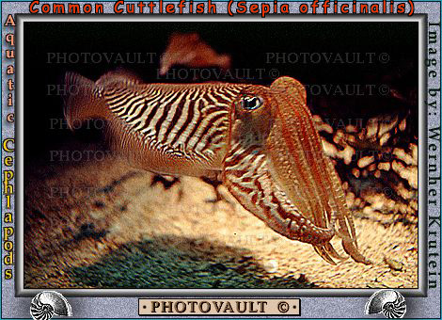

2. Janthina snail (possible source for techeiles according to Rav Herzog):
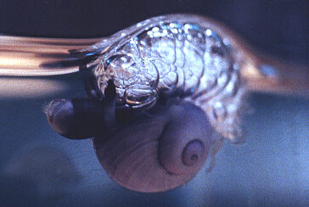

3. Murex trunculus shells (likely source according to Amutat P'til Tekhelet):
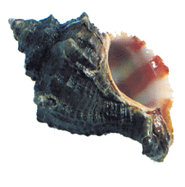
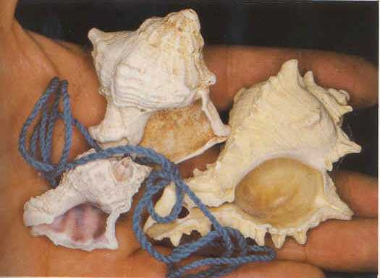

4. Hypobranchial gland in Thais haemastoma:
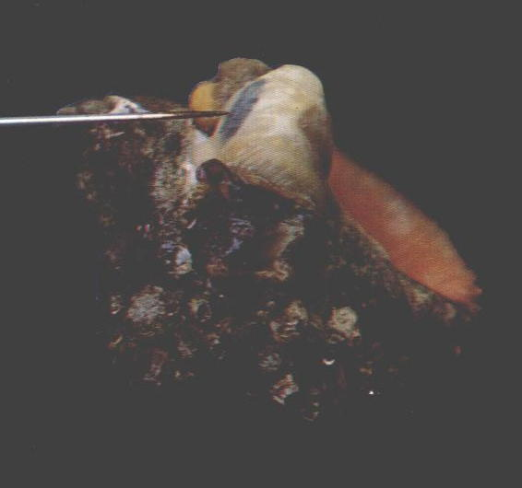

5. Murex trunculus spawning eggs:
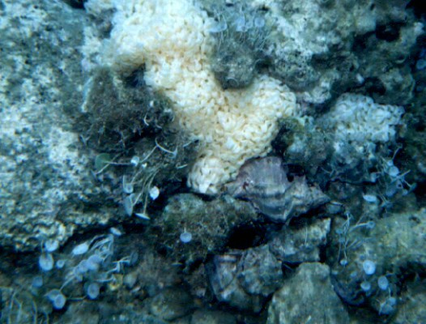

6. Murex trunculus seabed:
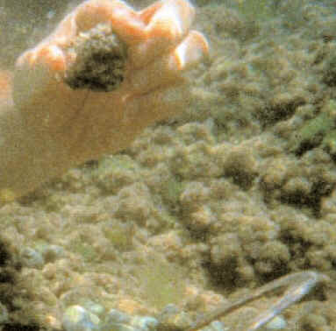

7. Murex with marine fouling giving blue hue:
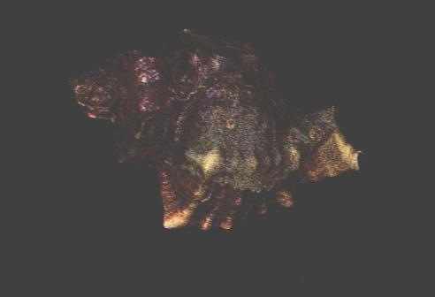

8. Coin of tyre -
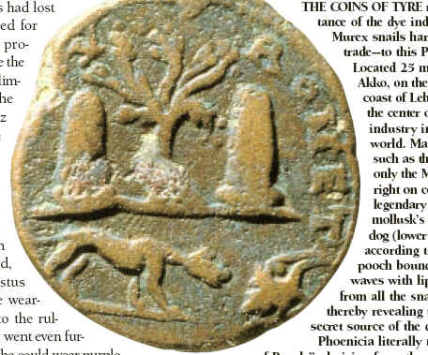

9. Shard from Tel Shikmona w/ purple murex dye:
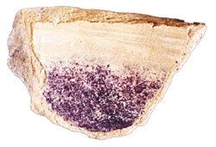

10. Murex Trunculus dye found in Masada by Prof. Zvi Koren - first known physical sample of tekhelet – Darker shade than one made by Ptil Tekhelet Foundation [b/c of different process of exposing to light?] but also from the Murex Trunculus snail – See NY Times Feb. 28, 2011 pg. A7:
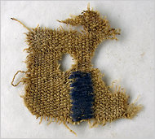

11. Indigoid plant - for kala ilan (fake techeiles):
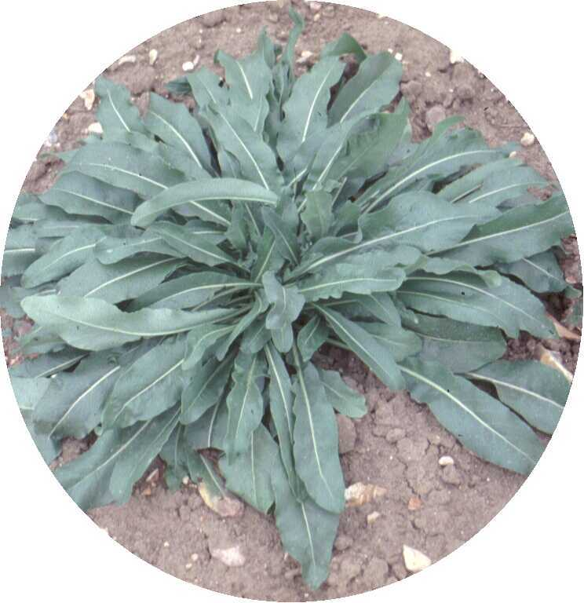

12. Indigo & dibromoindigo molecule (indigo molecule same for murex produced blue dye and plant produced indigo):
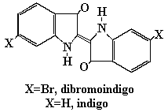

13. P'til Tekhelet factory in Kfar Adumim:


14. Methods of tying - 1) Radziner; 2) one understanding of the Rambam; 3) Vilna Gaon; 4) Chinuch; 5) Rav Natronai Gaon; 6) Rav Amram Gaon; 7) Rambam
(Note that number of blue strings is separate machlokes Rambam 1 string out of 8, Raavad 2 strings out of 8, Tosafos 4 strings out of 8 (all after folding))
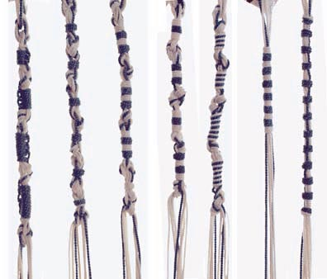

(Pictures taken from publicly available Internet sources)

