
BS"D

To: parsha@groups.io
From: Chaim Shulman <cshulman@gmail.com>
& Allen Klein <allen.klein@gmail.com>

INTERNET PARSHA SHEET
ON BEHAR - 5784

parsha@groups.io / www.parsha.net - in our 29th year! To receive this parsha sheet, go to http://www.parsha.net and click Subscribe or send a blank e-mail to parsha+subscribe@groups.io Please also copy me at cshulman@gmail.com A complete archive of previous issues is now available at http://www.parsha.net It is also fully searchable.
________________________________________________
Sponsored in memory of Chaim Yissachar z"l ben Yechiel Zaydel Dov.
In memory of Sara Masha bat R' Yaakov Eliezer a"h, Baila bat Arye Leib a"h & Ana Malka bas Yisrael a"h.
_______________________________________________
To sponsor a parsha sheet contact cshulman@gmail.com
(proceeds to tzedaka) ________________________________________________
from: Destiny Foundation/Rabbi Berel Wein <info@jewishdestiny.com>
reply-to: info@jewishdestiny.com
subject: Weekly Parsha from Rabbi Berel Wein
Home Weekly Parsha B’HAR
Rabbi Wein’s Weekly Blog
The parsha begins with the word that defines its name – b’har – on the mountain. The mountain naturally is Sinai and the Torah’s emphasis is to reinforce Judaism’s core belief that our Torah is God-given and not the work of a committee over centuries. This basic belief lies at the heart of many of the contentious disputes that have marked Jewish life over the ages.
While original splinter groups, such as the Saducees and the Karaites, did not openly deny the validity of the Written Torah as being godly in origin, they strenuously denied the holiness of the Oral Law of Sinai and denigrated its rabbinic interpretations and decrees. This led to serious splits within the Jewish people and to bitter recriminations that lasted centuries. In all these instances, the divinity of Torah and of its Oral Law always eventually won out. Deviant movements eventually fell away from the main body of the Jewish people, both individually and as a potent group in influencing Jewish life and mores.
The “mountain” referred to is the one at Sinai where the Torah was given to Israel. It is a difficult mountain to ascend, The Psalmist asks: “Who can ascend the mountain of God?” But as difficult as it is to ascend the mountain, it is even more difficult to remain there. The Psalmist again intones “who can maintain oneself, in the holiness of God’s place?” The struggle about maintaining the Jewish people on the mountain of God in belief and faith has been the hallmark of Jewish life over millennia. It has not abated in our time.
Jewish secularism comes in two different and divergent forms. One is simply that the Torah’s way of life and value system does not harmonize with modern society and its demands. Shabat, kashrut, etc. are all too restrictive to be functional in today’s world. The Jewish people cannot afford to be so different from the rest of the world. The mountain may have had its purpose at one time, but that time has now passed. New ideologies and circumstances have rendered it obsolete. So, for them the mountain no longer exists.
A second group denies the existence of the mountain altogether. There never was a mountain – it is all an urban legend fostered by the rabbis over the ages. In effect, our grandfathers were all liars or naïve believers in legends and stories for which there is no current historical scientific evidence. Aside from these two groupings there are groups who wish to be included in the religion of Judaism and who do not see themselves as being secular. But, in varying degrees, they follow the ideas of the Saducees and the Karaites though they essentially also deny that the mountain has anything to do with God and divine origins.
History shows that in the long run such philosophies and movements give way to the pressures of time and circumstance and eventually lose their influence and power. At the end of the day, only the mountain remains as it always has, challenging us to ascend it and maintain ourselves upon it.
Shabbat shalom.
Rabbi Berel Wein
__________________________________________________________
from: The Rabbi Sacks Legacy Trust <info@rabbisacks.org>
subject: Covenant and Conversation
COVENANT & CONVERSATION
Lord Rabbi Jonathan Sacks zt"l
Minority Rights
BEHAR
Rabbi Jonathan Sacks
One of the most striking features of the Torah is its emphasis on love of, and vigilance toward, the ger, the stranger:
Do not oppress a stranger; you yourselves know how it feels to be strangers, because you were strangers in Egypt.
Ex. 23:9
For the Lord your God is God of gods and Lord of lords, the great God, mighty and awesome, who shows no partiality and accepts no bribes. He defends the cause of the fatherless and the widow, and loves the stranger residing among you, giving them food and clothing. You are to love those who are strangers, for you yourselves were strangers in Egypt.
Deut 10:17-19
The Sages went so far as to say that the Torah commands us in only one place to love our neighbour but thirty-six times to love the stranger. (Baba Metzia 59b).
What is the definition of a stranger? Clearly the reference is to one who is not Jewish by birth. It could mean one of the original inhabitants of the land of Canaan. It could mean one of the “mixed multitude” who left Egypt with the Israelites. It might mean a foreigner who has entered the land seeking safety or a livelihood.
Whatever the case, immense significance is attached to the way the Israelites treat the stranger. This was what they were meant to have learned from their own experience of exile and suffering in Egypt. They were strangers. They were oppressed. Therefore they knew “how it feels to be a stranger.” They were not to inflict on others what was once inflicted on them.
The Sages held that the word ger might mean one of two things. One was a ger tzedek, a convert to Judaism who had accepted all its commands and obligations. The other was the ger toshav, the “resident alien”, who had not adopted the religion of Israel but who lived in the land of Israel. Behar spells out the rights of such a person. Specifically:
If any of your fellow Israelites become poor and are unable to support themselves among you, help them as you would a resident alien, so they can continue to live among you.
Lev. 25:35
There is, in other words, an obligation to support and sustain a resident alien. Not only does he or she have the right to live in the Holy Land, but they have the right to share in its welfare provisions. Recall that this is a very ancient law indeed, long before the Sages formulated such principles as “the ways of peace”, obligating Jews to extend charity and care to non-Jews as well as Jews.
What then was a ger toshav? There are three views in the Talmud. According to Rabbi Meir it was anyone who took it upon himself not to worship idols. According to the Sages, it was anyone who committed himself to keeping the seven Noahide commandments. A third view, more stringent, held that it was someone who had undertaken to keep all the commands of the Torah except one, the prohibition of meat not ritually slaughtered (Avodah Zarah 64b). The law follows the Sages. A ger toshav is thus a non-Jew living in Israel who accepts the Noahide laws binding on everyone.
Ger toshav legislation is thus one of the earliest extant forms of minority rights. According to the Rambam there is an obligation on Jews in Israel to establish courts of law for resident aliens to allow them to settle their own disputes – or disputes they have with Jews – according to the provisions of Noahide law. The Rambam adds:
“One should act towards resident aliens with the same respect and loving kindness as one would to a fellow Jew”
Hilchot Melachim 10:12
The difference between this and later “ways of peace” legislation is that the ways of peace apply to non-Jews without regard to their beliefs or religious practice. They date from a time when Jews were a minority in a predominantly non-Jewish, non-monotheistic environment. “Ways of peace” are essentially pragmatic rules of what today we would call good community relations and active citizenship in a multi-ethnic and multicultural society. Ger toshav legislation cuts deeper. It is based not on pragmatism but religious principle. According to the Torah you don’t have to be Jewish in a Jewish society and Jewish land to have many of the rights of citizenship. You simply have to be moral.
One biblical vignette portrays this with enormous power. King David has fallen in love and had an adulterous relationship with Batsheva, wife of a ger toshav, Uriah the Hittite. She becomes pregnant. Uriah meanwhile has been away from home as a soldier in Israel’s army. David, afraid that Uriah will come home, see that his wife is pregnant, realise that she has committed adultery, and come to discover that the king is the guilty party, has Uriah brought home. His pretext is that he wants to know how the battle is going. He then tells Uriah to go home and sleep with his wife before returning, so that he will later assume that he himself is the father of the child. The plan fails. This is what happens:
When Uriah came to him, David asked him how Joab was, how the soldiers were and how the war was going. Then David said to Uriah, “Go down to your house and wash your feet.” So Uriah left the palace, and a gift from the king was sent after him. But Uriah slept at the entrance to the palace with all his master’s servants and did not go down to his house.
David was told, “Uriah did not go home.” So he asked Uriah, “Haven’t you just come from a military campaign? Why didn’t you go home?”
Uriah said to David, “The Ark and Israel and Judah are staying in tents, and my commander Joab and my lord’s men are camped in the open country. How could I go to my house to eat and drink and make love to my wife? As surely as you live, I will not do such a thing!”
2 Samuel 11:6-11
Uriah’s utter loyalty to the Jewish people, despite the fact that he is not himself Jewish, is contrasted with King David, who has stayed in Jerusalem, not been with the army, and instead had a relationship with another man’s wife. The fact that Tanach can tell such a story in which a resident alien is the moral hero, and David, Israel’s greatest king, the wrongdoer, tells us much about the morality of Judaism.
Minority rights are the best test of a free and just society. Since the days of Moses they have been central to the vision of the kind of society God wants us to create in the land of Israel. How vital, therefore, that we take them seriously today.
__________________________________________________________
From: Rabbi Dovid Siegel <rdsiegel@torah.org> to: haftorah@torah.org date: May 22, 2024, 9:17 AM
Parshas Behar
Haftorah Commentary Parshas Behar
Yirmiyahu 32:6
This week’s haftorah reinforces the notion of our eternal relationship with our homeland, Eretz Yisroel. In the midst of a heavy Babylonian siege against Yerushalayim, the prophet Yirmiyahu was instructed to make a most puzzling transaction. Hashem informed Yirmiyahu that his cousin Chanamel was interested in selling his field and that Yirmiyahu should take full advantage of the opportunity. Although Yirmiyahu realized that the Jewish exile was imminent and that the Babylonians would soon take full possession of Eretz Yisroel he followed Hashem’s direction and arranged for the purchase. Yirmiyahu wrote a legal contract and paid a large sum of money for the land. Yirmiyahu then preserved the document in an earthen vessel to secure its existence until such evidence would be useful.
The prophet then directed his words to Hashem in bewilderment and questioned, “Since the Babylonian war machines are in full gear and the Jewish exile is already on its way, of what purpose is this sale?” Hashem responded, “I am the Master of all; is there anything beyond My capabilities? The Jewish people will return and re-engage themselves in such purchases and the land will be resettled.” The dialogue seems to be somewhat understood; however the purchase remains a mystery. Hashem had sent many prophets to the Jews regarding their eventual return from the Babylonian exile. Why was it necessary to demonstrate their return through this tangible experience? It is certainly fair to assume that Yirmiyahu would not derive any personal benefit from this purchase. After all, he was on the way to a long and hard exile of seventy years without any indication of personally returning to Eretz Yisroel. Why then was he instructed to waste his money in securing what, for him, was a seemingly useless transaction?
In response it can be suggested that this purchase taught the Jewish people a very meaningful lesson. One can easily imagine the feelings of the Jewish people during that era. They were finally confronted with the reality that they would soon be forced to leave their homeland. Although they had enjoyed the privilege of dwelling in the palace of the king for nearly one thousand years this privilege was now drawing to a close. Their minds were now focused on their unfortunate plight and they dreaded severing their ties with Eretz Yisroel. Although this painful thought surely tormented them but the reality was that their association with Eretz Yisroel was slowly beginning its decline.
At that exact moment the prophet Yirmiyahu was instructed to secure the purchase of a plot of land. Through this visible demonstration, the Jews were being told to rise above their inevitable predicament and to realize that their painful exile would only be temporary. They were encouraged not to despair and never to break their ties with their homeland, Eretz Yisroel. To reinforce this point their prophet Yirmiyahu was instructed to demonstrate his total faith in the Jewish people’s return. Yirmiyahu began setting his sights on the future and purchased property in preparation for the return. In Yirmiyahu’s mind this upcoming exile was but a passing phase and he rightfully preoccupied himself in life after the brief Babylonian stay. Yirmiyahu taught the Jews that the Jewish people never really leave Eretz Yisroel and that they are always bound to their homeland. He taught them that they truly belong to Eretz Yisroel and that Eretz Yisroel would always belong to them.
A similar lesson regarding our relationship with Hashem is revealed to us at the end of this week’s parsha. The Torah warns the Jews to adhere to all of Hashem’s mitzvos even after their exile from Eretz Yisroel. The Sforno explains the reason for this general warning which encompasses mitzvos that don’t specifically relate to Eretz Yisroel. He states that the Jews in exile could easily present the argument of rejection. After all, Hashem expelled the Jews from His land, indicative of His lack of interest in the Jewish nation. If so, what binds the Jewish people to the mitzvos, considering that Hashem severed His relationship with His people!? The Torah therefore reminds us that its obligations remain forever and that Hashem is forever concerned about His people. The Sforno notes that even after the Bais Hamikdash was destroyed the Divine Presence remains amongst the Jewish people. This phenomena is felt in our Bais Haknesses, synagogue and Bais Hamidrash, Torah study hall which continue to embody the Divine Presence at all times. (see Sforno’s comment to Vayikra 26:12) We learn from this that Hashem never forsakes His people and remains amongst them always because Hashem will always be our G-d and we will always be His chosen nation. Haftorah Commentary © 2023 by Torah.org.
__________________________________________________________
from: Yeshiva.org.il <subscribe@yeshiva.org.il>
Revivim by Rabbi Eliezer Melamed (R"Y Har Bracha)
The Parameters of the Mitzvah of “Lo Takifu”
Revivim Rav Eliezer Melamed
The mitzvah of “Lo Takifu” (not rounding the hairline) distinguishes the Jewish people through their hair, just as the mitzvah of circumcision distinguishes them through their bodies * HaKafa (rounding) is creating a hairless zone across the entire width of the head, so that there is no connection between the hair of the head and the beard hair * Some are lenient and shave the whole head, but in practice, one should be stringent regarding a Torah doubt and leave at least 4 millimeters in the area of the peyot (sidelocks)
The Torah commanded men not to remove the peyot of their heads or destroy the corners of their beards, as it is stated: “You shall not round the peyot of your head, nor shall you destroy the corners of your beard” (Leviticus 19:27). We will discuss the explanation of the mitzvah of “Lo Takifu” (not rounding the hairline).
‘Peyah’ in Hebrew means ‘corner’, and peyat harosh (peyot of the head) refers to the ends of the head hair. Generally, the hair on the head has a rounded appearance, and the peyot protrude from it, descending and connecting near the ear to the beard hair. Those who remove the peyot create a hairless circumference around the head hair, with no hair on the forehead, above the ear, and behind the ear. By removing the peyah, they create a hairless gap between the head hair and the beard hair, thereby rounding the head hair in a place where there is no hair.
The mitzvah of “Lo Takifu” distinguishes the Jewish people through their hair, just as the mitzvah of circumcision distinguishes them through their bodies, and the mitzvah of tzitzit (fringes) distinguishes them through their garments. As our Sages expounded on the verse “You are beautiful, my beloved, you are beautiful; your eyes are like doves” (Song of Songs 4:1), likening the Congregation of Israel to a dove: “Just as this dove is distinguished (unique and marked for its mate), so too are the Jews distinguished through their hair cutting, circumcision, and tzitzit” (Song of Songs Rabbah 4:2).
The Upper Boundary of the Peyah
The upper boundary of the peyah is the line opposite the upper end of the ear, and the line is raised slightly upward to distance oneself from the prohibition. The lower boundary is at the end of the bone opposite the middle of the ear, from which point and below is the lower cheek area, the part that moves during eating, which is already the beard area and not the peyah of the head:
The Stringent View on the Upper Boundary
Some poskim (Jewish law arbiters) are stringent regarding the upper boundary and hold that it extends from the upper end of the ear to the upper end of the forehead (Ketonet Yosef, Yoreh Deah 1):
And some are even more stringent for those who have receding hairlines above both sides of their forehead, that they should extend the line to their edges. This refers to one’s natural state before beginning to go bald (Yad HaKetanah, Avodah Zarah 6:71):
The Halakha Follows the Lenient View
However, from the words of the Rishonim (medieval authorities), the first view in Illustration 1 emerges as the accepted opinion. That is, the area of the peyah is adjacent to the ear and opposite its upper half. This is also implied by the term “peyah,” which means the edge of the head hair, and no more than the edge (this is the view of Tosafot, Ritva, as cited in Beit Yosef 181:9, and also the view of the Meiri; Responsa of the Radbaz 2:641; Shach 181:1; Chida in Yosef Ometz based on the Arizal).
The Customary Stringency Regarding the Lower Boundary
Some poskim are stringent to consider the area of the peyah to extend down to the lower end of the ear (based on the Rivan):
However, according to the halakha, the area of the peyah is until the lower part of the bone opposite the middle of the ear, and below that is already the area of the beard and not the peyot (Rashi, Ritva, Nimukei Yosef, Meiri and others).
Narrowing the Peyot
Some poskim say that it is forbidden to remove any hair from the area of the peyot (as implied by Semag, Hagahot Maimoniot, Nimukei Yosef).
On the other hand, some say that as long as hair is visible in the peyah that separates the hairless part on the forehead from the hairless part behind the ear, it is permissible (as implied by Rashi and Maimonides, and as stated by Zera Emet). Therefore, according to their view, it is permissible to narrow the peyah:
In practice, since this involves a doubt concerning a Torah prohibition, it has been ruled that across the entire width of the peyah area, “a hand must not touch it” (Shulchan Arukh Yoreh Deah 181:9; Yam Shel Shlomo, Bach, Levush, and many others).
Is it Permissible for One Who Shaves His Head to Remove the Peyot with a Razor or Haircut?
Even one who shaves all the hair on his head is forbidden to remove the peyot, since by doing so he creates a connection, a circumference without hair between the forehead and behind the ear (Nazir 57b; Shulchan Arukh 181:2).
However, some say that just as the prohibition of shaving the beard is only with a razor, so too the prohibition of removing the peyot is only with a razor, but with scissors, depilatory, or an electric razor that works like scissors, it is permissible to remove the peyot (Maimonides, Semag, Sefer Hachinuch, Raavid).
On the other hand, some say that regarding the peyot, the prohibition is to remove the hairs of the peyah, and it does not matter how the peyot are removed. Therefore, even one who removes the peyot with an electric razor violates a Torah prohibition, since in practice a hairless circumference is created between the forehead and behind the ears (Tosafot, Rabbeinu Yonah, Maharam of Rothenburg, Rosh, Rabbeinu Yerocham).
In Practice, One Should Be Stringent
In practice, since this involves a doubt concerning a Torah prohibition, one should be stringent. Even one who shaves his entire head is forbidden to remove the peyot, even not with a razor (Shulchan Arukh 181:2-3). Rather, he must ensure that the length of the hair in the peyah is at least 4 millimeters, at which point it can already be bent back towards its roots (Niddah 52b), and it has the significance of hair (Tosafot and Rosh). This is approximately the length of hair that grows in one week (Nazir 39b).
Typically, hair grows about 3 millimeters, or even less, in one week, so some instruct that 3 millimeters is sufficient. However, to remove all doubt, and also because some people’s hair grows faster, the instruction should be to leave at least 4 millimeters.
Nevertheless, since according to Maimonides, Semag, Sefer Hachinuch and others, it is permissible to shave the entire head with an electric razor without leaving any peyot at all, although in practice the ruling is to be stringent, one should not rebuke or reprimand those who follow the lenient view, since they have authorities to rely upon (Zera Yitzchak 12, as quoted in Darchei Teshuva 181:4; Shoeil U’Meishiv 1:97).
However, an educational institution is entitled to establish its own dress code, which may include requiring its students to follow the majority view of the poskim regarding the peyot, and even to reprimand and penalize those who do not follow this practice.
The Custom of the Meticulous
Even though according to the letter of the law, it suffices for the hair growing in the peyot area to be four millimeters long, since the peyot are an identifying sign of Judaism expressed through hair, many are meticulous to grow them out to a visibly longer length, and some even curl them. However, many do not follow this stringency, and there are even G-d-fearing individuals, including rabbis, who do not grow their peyot longer than the basic legal requirement.
Is it Permissible to Grow the Hair on the Head Long, while keeping the Peyot Trimmed Short?
A: From the perspective of the prohibition of “Lo takifu,” as long as the hair in the peyot area is four millimeters long, there is no prohibition. However, from the perspective of the prohibition of “You shall not follow their practices,” there is a doubt whether this would constitute a biblical prohibition, or perhaps a rabbinic prohibition, or perhaps just an improper custom. But more on that another time.
Rabbi Eliezer Melamed
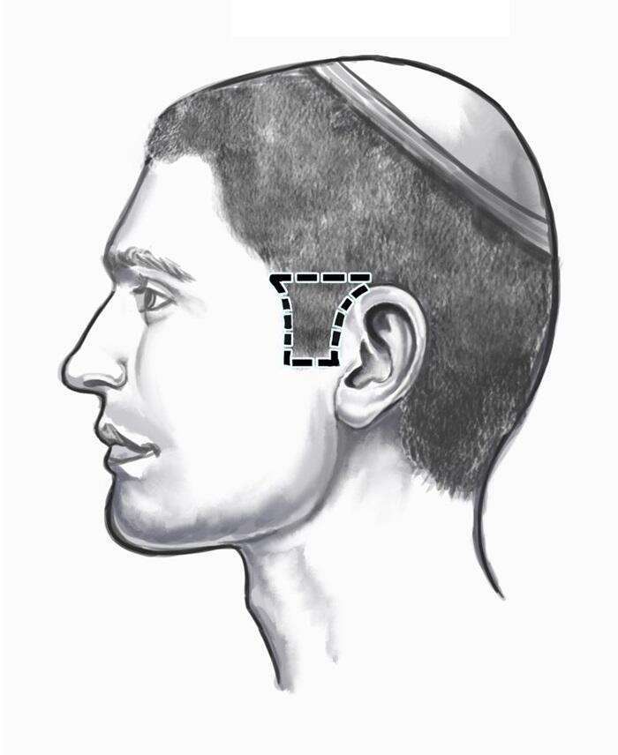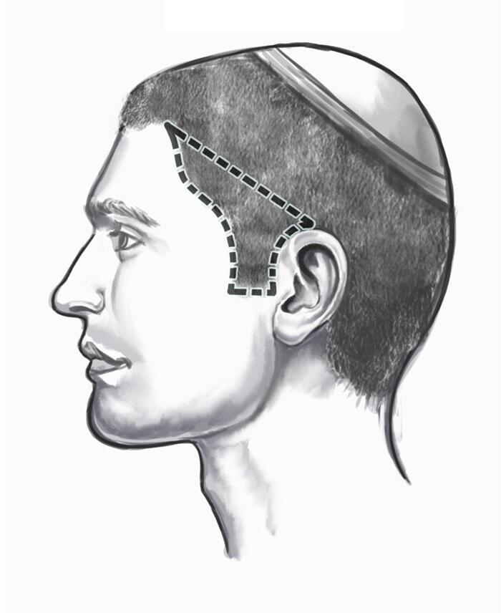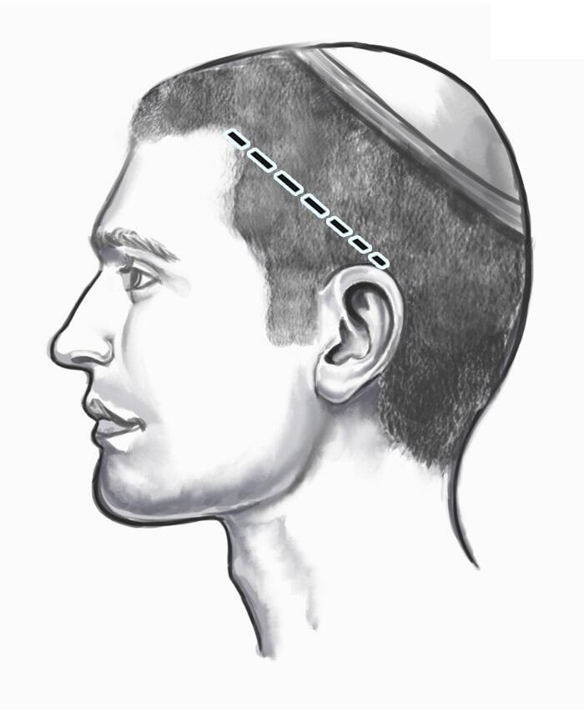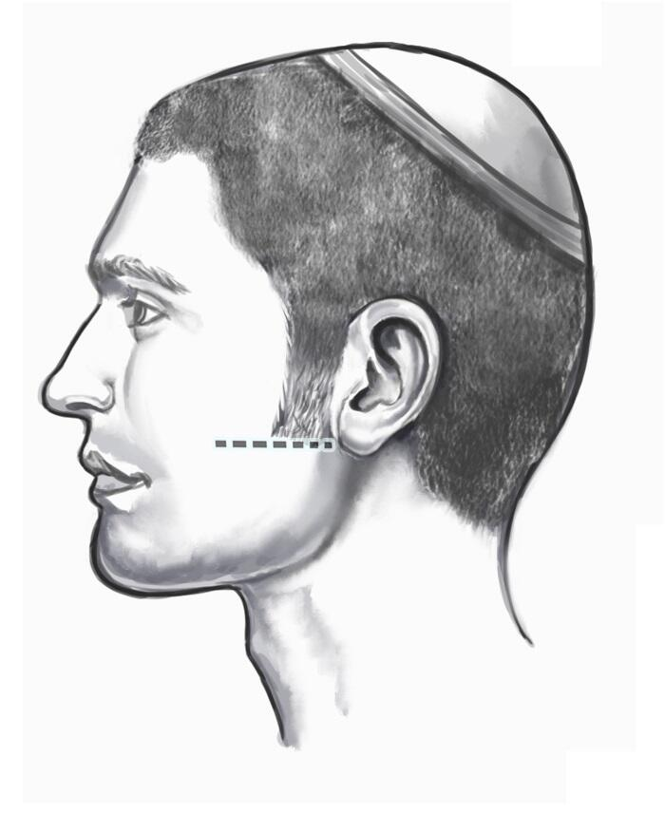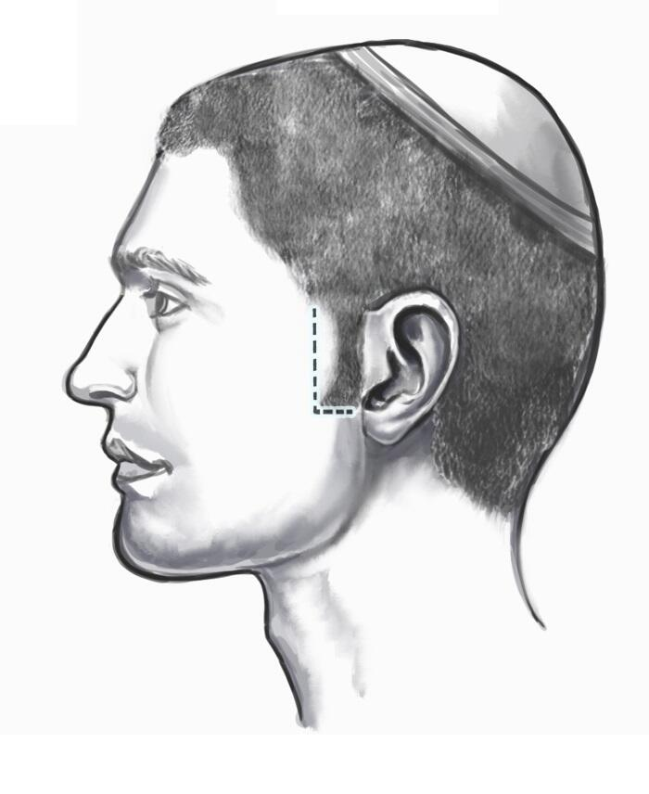
__________________________________________________________
from: Rabbi Yissocher Frand <ryfrand@torah.org>
to: ravfrand@torah.org
date: May 22, 2024, 4:10 PM
Rabbi Yissocher Frand
Parshas Behar
Rebbi Teaches a Lesson So Clear That His Students Could Taste Its Message
These divrei Torah were adapted from the hashkafa portion of Rabbi Yissocher Frand’s Commuter Chavrusah Tapes on the weekly portion: #1292 – The Price of Fish for Shabbos Went Sky High – What Can the Community Do? Good Shabbos!
The pasuk in Parshas Behar says: “Each of you shall not aggrieve his fellow, and you shall fear your G-d, for I am Hashem, your G-d.” (Vayikra 25:17). The Gemara (Bava Metzia 58b) teaches that this pasuk is not referring to cheating a person in business, but rather it is referring to a prohibition called “Ona’as Devorim” – saying hurtful things to someone. This is also not referring to humiliating someone in public. Merely saying hurtful things to someone even privately is a mitzvas lo saaseh (negative Biblical prohibition) called “Lo so’nu ish es amiso“.
The Medrash relates that Rabbeinu haKadosh made a celebratory meal for his talmidim (students). He served them tongue, both soft pieces of tongue as well as hard pieces of tongue, on the same platter. As would be expected, the students all started picking out the tastier soft pieces of tongue and left over the hard pieces on the platter. Rabbeinu haKadosh remarked: “Look what you are doing: Just like you pick out the soft pieces and leave behind the hard pieces, so too when you talk to each other with your tongues, you should engage in “soft speech” rather than “hard speech.” In other words, he was giving them a mussar schmooze about Ona’as Devorim.
Why did Rabbeinu haKadosh use such a novel teaching method? Rabbeim, roshei yeshivos, and mashgichim have been speaking about Ona’as Devorim since the Ribono shel Olam uttered the pasuk Lo so’nu ish es amiso. Typically, if a mentor wishes to impress upon his disciples the message that they should not speak harshly with their friends, he gets up in the Beis Medrash and gives a schmooze on that topic. What did Rebbi do? He made a seudah and served tongue. When everyone chose the soft pieces of tongue, he told them “Look. This is how you should be speaking with your friends. Speak with a soft tongue.” Why didn’t he just use the time-honored method of giving a typical mussar schmooze? That certainly would have been a lot less expensive.
Rav Berel Soloveitchik, z”l, (Son of the Brisker Rav, Rav Yitzchok Zev Soloveitchik) said as follows: If Rebbi would have given a typical mussar schmooze, everyone would have thought that he was speaking about someone else. (“Me? I never talk like that! Maybe once in a great while I will give someone a dig. Maybe when someone gets me angry, I might answer back a little sharply. That is not the “lashon kasheh” that Rebbi is speaking about!”)
An overwhelming percentage of talmidim assume they speak lashon rakka (soft speech), perhaps occasionally with a little salt on it. Such a schmooze would not have accomplished very much. Rebbi wanted to demonstrate to them how careful they each were when taking the edible kind of tongue to see to it that they were taking only soft tongue. He then was able to hit home with his mussar message: As careful as you were when choosing the ‘soft tongue,’ that is how careful you need to be in choosing your words.
Rabbeinu haKadosh was a good Rebbi. He demonstrated his lesson to his talmidim in a way they could sense. It was not merely a cerebral exercise utilizing intellectual facilities. It was such a clear lesson that they could taste it in their mouths, and it was a lesson that they would never forget.
Taking Interest Diminishes a Person’s Faith in the Master of the Universe
Parshas Behar is one of several places in Chumash where the Torah teaches the prohibition against taking interest (ribis): “Do not take from him interest and increase; and you shall fear your G-d – and let your brother live with you.” (Vayikra 25:36) There is a mitzvah to lend people money, however, the money must be lent without interest. Transgressing this prohibition results in serious punishment. “Rav Shimon (bar Yochai) says: Those who lend with interest lose more than they gain.” (Bava Metziah 75b).
What is Rav Shimon talking about? If he were talking about punishment or about loss of reward in the world to come, then the same comment can be made about any mitzvas lo saaseh: Don’t eat chazir! Ay – it is geshmak! It doesn’t matter – more than you enjoy it, you will suffer for that enjoyment in the World to Come.
What then is so special about the ribis prohibition that prompts Rav Shimon to say “More than you profit, you will lose?”
There is a beautiful Kli Yakar in this week’s parsha that gives an interesting explanation as to why the Torah prohibits ribis. The Kli Yakar defines the reason for this mitzvah as causing man to lose faith in the Master of the Universe. How does taking interest diminish a person’s bitachon in the Ribono shel Olam?
The Kil Yakar explains that in virtually every business venture, a person can either make money or lose money. People who are in a business where they do not receive a set salary, rather they work on commission, see this all the time. Likewise, this is true of people who invest money. The investment can go through the roof and become a phenomenal success. However, sometimes a product is a hot item but then a competitor comes out with something that is a little hotter. Everyone runs to the competitor and the first person loses his pants. Every person in business realizes that they need siyata d’Shmaya (Divine help) to succeed. Inevitably, they need to turn to the Ribono shel Olam to pray for their success in business, and this increases their emunah and bitachon.
This is not true, says the Kli Yakar, of those who lend out money with interest. Given, of course, that the loan is secure, it is money in the bank. If the debtor cannot pay, the lender will collect from the guarantor of the loan or he will foreclose a mortgage or take collateral. He has a high degree of security that he is in a “Win-Win Operation.” Lending is a great business – like money in the bank!
As a result of this surefire way to make profit, a person may lose his bitachon. “I have been doing this business for the last who knows how many years. What can go wrong?” A person becomes distanced from the whole concept that the Ribono shel Olam runs the world. He thinks that he is running the show and forgets that He is running the show. If a person loses bitachon and thinks that the Ribono shel Olam doesn’t run the world, when he hits a crisis, he has no peace of mind.
The Chovos haLevovos notes that one of the tremendous attributes of a person who is a true believer (as opposed to someone who just pays “lip service” to the concept of emunah) is that he has a psychological safety net when unpleasant things in life hit him. “I know the Ribono shel Olam is with me; I know that He has been watching over me; I may not know why He is doing this to me, but I know that the Ribono shel Olam is in charge and He knows what He is doing and I have full faith in Him.”
This has a tremendous calming effect on a person. There is a certain serenity that accompanies people who truly possess the attribute of emunah and bitachon. They lead serene lives knowing that the Master of the Universe is fully in charge. This is what Rav Shimon bar Yochai meant when he said, “More than they gain, they lose.” Yes, they are making a profit and yes, the profit is in the bank. But they become less baalei bitachon. As a result, they may live troubled, worried, anxiety-filled lives. It is not worth it.
I recently heard a story involving a Rav Dovid Bleicher, who had been the Rosh Yeshiva in the Novardok Yeshiva during the war. As was typical in the Yeshivas in Europe, finances were very tight. He raised money and finally obtained food for the talmidim. A bit later, Pesach was approaching and there was no matzah. Where would he get flour for matzah?
After much effort, he was somehow able to procure enough flour to supply the whole Yeshiva for the entire week of Pesach. He put that precious flour upstairs in the attic of the Yeshiva. That night there was a terrible wind storm and part of the roof blew off. It rained onto the flour and the flour became chametz. “The City of Shushan was bewildered.” (Esther 3:15) What is going to be?
Rav Dovid Bleicher brought in the entire Yeshiva and told them: I want to ask you four questions:
1. Who commanded us to eat matzah on Pesach?
2. Who helped me obtain the flour for the matzah?
3. Who brought the storm that caused the rain to leak through the roof?
4. Who caused the flour to leaven after it became wet from the rain water?
To each question the students answered unambiguously “The Ribbono shel Olam.” Rav Bleicher concluded, “So everything happened because of Him and He knows that we need flour for matzah on Pesach. Undoubtedly he will provide us with other flour.” In other words, if Hashem is running the world and He is calling the shots, then if He wants us to eat matzah on Pesach, He will get us more flour.
The night of Bedikas Chometz, the mail arrived with a tremendous check. The Rosh Yeshiva was able to buy more flour for Pesach and they all had matzah. This is the serenity of a person who is a baal bitachon.
Last Sunday, the Ner Israel Kollel had their Chinese Auction fundraiser. The day before yesterday, when I was walking out of the office, I saw a kollel yungerman carrying a box with five Playmobil sets. If you have children, you know that Playmobil is a very popular toy (like Tinker Toys or Lincoln Logs in our days).
I asked him “Did you win that at the Kollel auction?” He said, “Yes, and not only that, but I won a prize at Rabbi Berger’s shul’s auction for the past three or four years.” I inquired of him, “What is the trick?” He told me “It is because I have been working of my midas habitachon for the last four years and therefore when my wife left for the auction, I told her, “You are going to win tonight!”
Now, does that mean that someone who has midas habitachon will always win auctions? No. Does it mean that if someone has midas habitachon, everything in his life is going to turn out perfect? No. But, this person had a certain confidence and serenity because of his midas habitachon. It is an amazing phenomenon that this happened. Again, it does not follow that someone can say “Okay, I am going to work on my midas bitachon and then I am going to win the Power Ball.” It does not work like that.
However, this kollel yungerman made such a profound impression on me. “I worked on midas habitachon. I knew that I needed a Playmobil for my kids and I was confident that it would happen.” The upshot is not “Have bitachon and you will win the lottery.” The upshot is “Have bitachon and you will have a more calm and serene life.”
__________________________________________________________
From: TorahWeb <torahweb@torahweb.org>
Thu, May 23, 6:14 PM (6 hours ago)
Rabbi Ahron Lopiansky
Two Lessons: Shmitah, and Yovel
This week's parsha starts with two mitzvos that are very central to reinforcing the belief of Hashem being in our lives. Just as shabbos serves to ingrain in us the sense that Hashem is the creator of the world and nothing exists without His creating it, so too do we mark the shmitah year as a "shabbos". On shabbos we demonstrate, via the cessation of all our mundane activities, that on the day that Hashem stopped creating new things in the world nothing further came into being. Shmitah is very similar; it is the cessation of all agricultural activity in Eretz Yisroel, letting the land lie fallow. The passuk (Vayikra 25:4) connects these mitzvos by saying that shmitah is a "shabbos for Hashem". Rashi explains that "shabbos for Hashem" teaches us not to think that we let the land lie fallow because it helps increase productivity (as is usual in many agricultural settings), rather we do so to emphasize that Hashem is the creator of all. He is the one who apportions out the land and causes all to grow. When He "rests", so to speak, everything ceases to grow. That is the message of shmitah, and it parallels the message of shabbos.
After seven shmitah cycles we arrive at the fiftieth year, known as yovel, which has both the halachos of shmitah as well as many other halachos which pertain to it that go far beyond those of shmitah. The laws of all slaves returning home and of all fields that were sold returning to the original owner are the core laws of yovel, which is also some sort of shabbos but includes and extra dimension that we're not familiar with from the weekly shabbos or the shmitah shabbos. What is the extra dimension of yovel which, like the other two shabbosos, is a reminder of a core belief in Hashem, but is also different than shmitah?
When we believe in Hashem, there are actually two stages or phases of what we believe in. Hashem is described as "kadmon", which means prime, for it is He who brought everything into existence and nothing could exist without Him. This means that all that is produced, regardless of how, ultimately comes from Hashem. On shabbos and shmitah we demonstrate that when Hashem has finished acting or doing, everything ceases, thereby establishing the concept of Hashem's existence being primary and bringing all else into being.
There is a deeper belief that must be ingrained in us, which is that Hashem created the world for a purpose and gave us the opportunity to realize that purpose. We have free will so that we can implement what Hashem wants in this world and be credited for that implementation. But even if we do not choose to do what's right, even if we fall short of being the ones to complete the world and be a vehicle for achieving Hashem's ultimate goal in the world, the goal will nonetheless be reached. Hashemi's will, in the sense of the destiny of the world, will come to be either with our help or despite our hindrance.
The Ramchal speaks a lot in Da'as Tevunos about the two parallel dynamics which operate in the world at all times. There is the dynamic of mishpat, which means justice, law, and so on, which means that we are allowed to make choices and act based on our choices, and the results and consequences of our actions become reality around us. There is a second dynamic and that he calls the derech ha'yichud, which means Hashem's oneness or exclusiveness. It means that when viewed from the perspective of yichud, nothing is helping or hindering the world, rather everything is coming to its tachlis, its destination. He explains that we at this time cannot reconcile these two dynamics, all we can do is examine each one separately, but at the end of days the two will come together.
The central feature of yovel is that everything reverts to what it was meant to be at the very beginning. Every person's portion of the land in Israel comes back to him; all Yisroelim who were slaves go back to becoming the freeman that they're meant to be. This is why yovel is referred to as, "olamo shel yovel - the world or universe of yovel". Specifically, when the passuk says that a Jewish slave who declares that he wishes to remain with his master remains with him until yovel, the duration of his stay is called, "l'olam - forever". "Forever" in our eyes stretches until the yovel, which marks a self-contained bubble of time having come to its destination. A person may go through many trials and tribulations to the point that he became a slave, but when yovel arrives he comes back to being who he was meant to be. Land that was sold may pass through many owners, but at the end it comes back to the person that Hashem had designated it for. Thus, all comes back to the place that Hashem meant it to be.
Hashem is referred to "first" and "last" - "Ani rishon, Ani acharon - I am the first I am the last". "First" means creator and initiator, while "last" means destination. Our first fundamental belief in Hashem is that He created everything and everything came into being because of His say so and is sustained by His will. We celebrate this and mark it on every shabbos and every shmitah. When the designated time for creation and work has come to an end, nothing is happening - work has ceased and the land is fallow. But then, over an entire olam, meaning an entire universe of time, we come to a point where we understand a much more profound truth of Hashem which has to do with hashgacha or Divine Providence. No matter how far something has strayed away, in the end it inevitably comes to the point that Hashem had destined for it. In all that a person does, he can be a partner in helping reach Hashem's goals. But if he does not contribute towards achieving the goals or, even worse, if he has hindered the process, at the end of days it matters not for all comes back to where Hashem had destined it to. "I am the first I am the last".
More divrei Torah from Rabbi Lopiansky
More divrei Torah on Parshas Behar
© 2024 by TorahWeb Foundation. All Rights Reserved
TorahWeb.org 94 Baker Ave Bergenfield, NJ 07621-3321
_______________________________________________
Drasha
By Rabbi Mordechai Kamenetzky
Parshas Behar
... But Were Afraid To Ask
The Torah does not usually leave room for official questions of faith. It tells us, in no uncertain terms, what our responsibilities are and the commitment we must make to be observant Jews. Every mitzvah entails sacrifice. Sometimes it requires a monetary commitment, sometimes a commitment of time and morals. Not often does it consider the human trials one encounters in mitzvah performance. They are our problem and we must deal with them as human beings and as Jews.
Yet this week the Torah uncharacteristically provides leeway for those who may waver in their commitment.
In Parshas Behar the Torah charges the Jewish people with the laws of shmittah. Every seventh year, we are told that the land of Israel is to lie fallow. No work is to be done with the earth. There is not to be a harvest, nor may the ground be sown or reaped.
Observing shmittah is a true test of faith. Imagine! One must not harvest his grain but instead rely on pure faith for his daily fare. Yet the Torah does not leave us with the austere command. The Torah deals directly with the human emotion related to the issue. In Leviticus 25:20 the Torah foretells a human side. “And if you will say in your heart, ‘what shall we eat in the seventh year, behold the land has not been sown nor has it been reaped?'” Hashem reassures the people that His bounty will abound in the sixth year and they will live the seventh year in comfort.
This is not the only time the Torah realizes human wariness. In reference to the command of conquering the Land of Canaan, the Torah states in Deuteronomy 7:17: “Perhaps you shall say in your heart, ‘these nations are more numerous than me. How will I drive them out?'” Once again Hashem reassures His nation that He will not forsake them.
The question is glaring. Why does the Torah answer to human psyche? Why doesn’t the Torah just command us to let the land lie fallow, or conquer the Land of Canaan? If there are problems or fears in our hearts, they are our problems. Those fears should not be incorporated as part of the command.
Isidore would meet his friend Irving every other week while doing business. “How are you Irving?” Isidore would always ask. “How’s the wife and kids?” Irv would always grunt back the perfunctory replies. “Fine.” “A little under the weather.” “My son Jack got a job.”
This one sided interrogation went on for years until one day Isidore exploded. “Irv,” he said abruptly. “I don’t understand. For six years I ask you about your wife, your kids, and your business. Not once mind you, not once did you ever ask me about my wife, my kids, or my business!
Irv shrugged. “Sorry, Izzie. I was really selfish. So tell me,” he continued, “how is your wife? How are your kids? How is your business?”
Izzie let out a sigh of anguish and began to krechts. He put his hand gently on Irv’s shoulder, tightened his lips, and shook his head slowly. “Don’t ask!”
Reb Leible Eiger (1816-1888) explains that there are many questions of faith that we may have. The faithful may in fact fear the fact that there is fear. “Is it a flaw in faith to worry?” “Am I committing heresy by fearing the enemy?” “Am I allowed to ask?” The Torah tells us in two places, “you will have these questions. You will ask, ‘how am I going to sustain myself and family?’ “You will worry,” ‘how will I conquer my enemies?’ ‘Will I be destroyed?'” The Torah reassures us that there is no lack of trust by asking those questions. We mustn’t get down on ourselves and consider questions a breach of faith. Life and sustenance are mortal attributes. They warrant mortal fear.
Adam, the first man was originally blessed with eternal life without having to worry for his livelihood. After sinning, he was cursed with death and was told that he would eat by the sweat of his brow. The Torah assures us that it is not only human but also acceptable to worry about these two issues — one’s livelihood and survival, as long as we believe in the reassurances about those worries.
Good Shabbos!
__________________________________________________________
from: Rabbi Kaganoff <ymkaganoff@gmail.com>
to: kaganoff-a@googlegroups.com
date: May 22, 2024, 12:06 PM
subject: Conversion Conundrums
Contemporary Conversion Conundrums
By Rabbi Yirmiyohu Kaganoff
Question #1: Who is a Jew?
Are Jews an ethnic group?
Question #2: What is a Jew?
Or is Judaism a religion?
Question #3: Teaching a Non-Jew?
May I teach Torah to someone who is interested in becoming Jewish?
Introduction
When our ancestors accepted collective responsibility to observe the Torah, they did so by performing bris milah, immersing in a mikveh and offering a korban. So, too, a non-Jew who is joining the Jewish people is entering the same covenant and follows a similar procedure (Kerisus 9a). When the bris milah is performed, a special form of the brocha is recited: lamul es hageir. Immediately after immersion in the mikveh, the new convert recites a brocha, al hatevilah.
Since, unfortunately, no korbanos can be offered today, an individual may join the Jewish people and become fully obligated to fulfill all the mitzvos without fulfilling this korban requirement. (We derive from a pasuk that geirim are accepted even in generations that do not have a Beis Hamikdash.) However, when the Beis Hamikdash is iy”H rebuilt, every geir will be required to offer a korban olah, which is completely burnt on the mizbei’ach (Rambam, Hilchos Issurei Bi’ah 13:5). Those who have already become geirim will be obligated to bring this korban at that time.
The privilege of becoming a geir tzedek comes with very exact and exacting guidelines. On a technical level, the geir is accepting responsibility to perform mitzvos. Through the geirus procedure, he creates an obligation upon himself to observe mitzvos (Birkas Shemuel, Kiddushin #15).
Who is a Jew?
To the non-Jewish or non-observant world, the definition of a Jew is based on ethno-sociological criteria. But to the Torah Jew, the definition of a Jew is someone who is a member of a people obligated to fulfill the Torah’s commandments. For this reason, it is axiomatic that joining the Jewish people means accepting the responsibility to observe mitzvos (kabbalas mitzvos). This concept, so obvious to the Torah Jew, is almost never appreciated by the non-observant. This is why a not-yet-observant Jew often finds the requirements for giyur to be “unrealistic” or “intolerant.” In reality, attempting to bend the Torah’s rules reflects a lack of understanding of the concept of “commandment” and the unique status of the Jewish people as a nation whose definition is: living according to the laws of Hashem.
In other words, the answer to our opening question -- are Jews an ethnic group or is Judaism a religion? -- is that the Jewish people are a divinely created religious community chartered with a specific relationship with our Creator. He who made the Rules instructed that others desiring to join the community may do so, but those who choose to leave it may not dispense with their obligation. Thus, we are not technically “an ethnic group,” because you cannot “join” one. On the other hand, we are not simply a “religion” either, because someone who does not believe in the tenets of Judaism may still be Jewish.
Desire to convert
Someone requesting to be converted to Judaism is discouraged from doing so. As the Gemara (Yevamos 47a) says, we ask him, “Why do you want to convert? Don’t you know that Jews are persecuted and dishonored? Constant suffering is their lot! Why do you want to join such a people?”
Why discourage a sincere person from joining Jewish ranks? Shouldn’t we promote this noble endeavor?
This is because even a sincerely motivated convert may not successfully persevere when encountering major adversity. We can never be certain what the future will bring, but placing obstacles in the path to conversion helps a potential geir who might later regret the decision. As the Gemara explains, we tell him, “Until now you received no punishment if you did not keep kosher. There was no punishment if you failed to observe Shabbos. If you become Jewish, you will receive very severe punishments for not keeping kosher or Shabbos!” (Yevamos 47a)
A different method of discouraging someone from converting is to explain that someone not Jewish who observes the seven mitzvos benei Noach properly merits olam haba, without becoming obligated to keep all the Torah’s mitzvos.
The beis din overseeing the conversion attempts to ascertain that the candidate wants to become Jewish for the correct reasons. If we suspect that there is an ulterior reason to convert, the potential convert is not accepted, even if they commit to full mitzvah observance. The Gemara and the Rambam note that a beis din should be aware that a man may seek conversion to allow him to marry a Jewish woman, or a woman because she wants to marry a Jewish man. The Gemara and the Rambam rule that we should reject these conversion candidates, because their motivation is not fully sincere.
If the potential convert states that he/she accepts responsibility to fulfill all the mitzvos, we usually assume that the geirus is valid. However, what is the halacha if the potential convert declared acceptance of all the mitzvos, but the individual’s conduct indicates that this was merely lip service? For example, what happens if the convert eats non-kosher food or desecrates Shabbos immediately following his conversion procedure? Is he considered Jewish? This question is disputed by Rav Avraham Yitzchak Kook, first Chief Rabbi of the new yishuv in pre-state Israel, and Rav Chayim Ozer Grodzenski, accepted posek hador and rav of Vilna until his passing in 1940, in which Rav Kook rules that the geirus is valid, as long as the beis din believes, at the time of the conversion, that the person is fully accepting observance of the mitzvos, whereas Rav Chayim Ozer rules that the geirus is invalid. Rav Moshe Feinstein rules that, when it is clear that the person never intended to observe mitzvos, the conversion is invalid. The person remains a non-Jew, since he never undertook kabbalas mitzvos, which is the most important component of geirus (Shu”t Igros Moshe, Yoreh Deah 1:157; 3:106).
Accepting mitzvos
As mentioned above, kabbalas mitzvos is a verbal acceptance to observe all the Torah’s mitzvos. We do not accept a convert who states that he is accepting all the mitzvos of the Torah, except for one (Bechoros 30b). Rav Moshe Feinstein discusses a woman who was interested in converting and was willing to fulfill all the mitzvos, except the requirement to dress in a halachically appropriate manner. Rav Moshe rules that it is questionable if her geirus is valid (Shu”t Igros Moshe, Yoreh Deah 3:106).
Sincerity
It is important to accept only converts who want to join the Jewish people and observe the mitzvos for sincere reasons. This is why converts are not accepted whenever there is political, financial, or social gain in being Jewish. For example, no converts were accepted by batei din in the days of Mordechai and Esther, nor in the times of Dovid and Shelomoh, nor will geirim be accepted in the era of the Moshiach. In these era, we assume that the interest in conversion is influenced by the financial or political advantages in being Jewish (Yevamos 24b). For this reason, Megillas Esther (8:17) refers to misyahadim, “those who made themselves into Jews,” without acceptance by the official batei din. Similarly, in an earlier era, unlearned Jews created ersatz “batei din” during the reign of Dovid Hamelech, converting people against the wishes of the beis din hagadol (Rambam, Hilchos Issurei Bi’ah 13:15).
The Rambam explains that the “non-Jewish” wives that Shelomoh married were really insincere converts. In his words, “In the days of Shelomoh, converts were not accepted by the official batei din…however, Shelomoh converted women and married them… and it was known that they converted for ulterior reasons and not through the official batei din. For this reason, the pasuk refers to them as non-Jews… furthermore, the end bears out – because they worshipped idols and built altars to them” (Rambam, Hilchos Issurei Bi’ah 13:15-16).
A successful spouse trap
In all of the above instances, where there is an ulterior motive to convert, should someone manage to become converted, the giyur is valid, provided that the individual, indeed, accepted full mitzvah observance.
Why is this valid bedei’evid?
Since they want to marry this particular spouse, and the only way to accomplish this is by accepting mitzvos and becoming Jewish, he or she has accepted keeping the mitzvos (Ritva and Nimukei Yosef, both to Yevamos 24a).
Because of this rule, we do not accept someone who is converting because he or she wants to marry someone who is Jewish, even if the convert is absolutely willing to observe all the mitzvos (Yevamos 24b; Menachos 44a). However, if the convert followed all the procedures, including full acceptance of all the mitzvos, the conversion is valid, even though we disapprove of what was done (Rambam, Hilchos Issurei Bi’ah 13:15-18).
Times have changed
This assumption was true at the time of the Gemara and the Rambam, when societal norms did not permit someone to marry Jewish without being part of a Jewish community that was halachically observant. In the contemporary world, a non-Jew can marry someone Jewish without any commitment to the Jewish people. Does this affect the status of someone who wants to convert to Judaism for the sake of marriage?
The two greatest Litvishe halachic authorities of pre-war Europe both contended that it does affect the geirus, but they reached diametrically opposite conclusions. Rav Chayim Ozer noted that, since in the contemporary world, any couple can get married regardless of their religious affiliation, someone wanting to convert and observe mitzvos for the sake of marriage may be accepted for conversion lechatchilah (Shu”t Achiezer 3:27).
At the same time, the rav of Kovna was the Devar Avraham, Rav Avraham Kahana-Shapiro, who, upon seeing Rav Chayim Ozer’s responsum, wrote him a letter disagreeing with his conclusion. The Devar Avraham contended the exact opposite: that since someone today may marry out of their religion, there is no longer anything to prove that the potential convert indeed accepted to observe mitzvos (Shu”t Devar Avraham 3:28). This is based on the approach, quoted above in the name of the Ritva and the Nimukei Yosef, that kabbalas mitzvos that is not completely sincere, but is somewhat compelled by the desire to marry this particular individual, is acceptable only when there is no other way for him or her to marry this particular spouse.
Hillel
We are all familiar with the famous stories of Hillel, which present a halachic conundrum with very differing resolutions. Let me review the situations as they are presented by the Gemara: Three different non-Jews approached Hillel, the first requesting that he convert him on condition that Hillel teach him only the Written Torah and stating that he rejects the authenticity of the Oral Torah. The second requested that Hillel convert him on condition that Hillel teach him the entire Torah while the convert would remain standing on one foot, and the third, on condition that he can become the kohein gadol. Hillel accepted all of them as righteous converts (Shabbos 31a), and then convinced them to study the rest of the Torah.
This Gemara presents a very great difficulty. In what way did any of these converts accept the Torah? The first one certainly did not – he only accepted the authenticity of the Written Torah; therefore, his conversion should be invalid.
Tosafos (to Yevamos 109b s.v. Ra’ah) answers that Hillel realized that all three of these gentlemen were sincere and would keep the entire Torah.
The Maharsha (Shabbos 31a) understands that Hillel did not convert these three men immediately, but accepted them as students to teach them Torah. In his opinion, it is permitted to teach Torah to an individual interested in converting, since its purpose is to enable him or her to observe mitzvos properly as a Jew.
On the other hand, Rabbi Akiva Eiger holds that Hillel converted the three of them immediately, and only after they were halachically Jewish was he permitted to teach them Torah, In his opinion, it is forbidden to teach Torah to a non-Jew simply because he is in the process of conversion.
Thus, our opening third question -- May I teach Torah to someone who is interested in becoming Jewish? – is a dispute among these acharonim.
Common practice is to follow the Maharsha’s approach. Therefore, if the beis din is convinced of the sincerity of a potential convert, they will usually recommend an appropriate program whereby he or she can learn about Judaism and become knowledgeable in mitzvah observance and proper Torah perspective, to prepare them for their eventual conversion to Judaism.
Typical anecdotes
I shall now present to our readers various situations that I know of concerning potential converts.
Tom
Tom was converted by a non-Orthodox rabbi because his father wanted him to be of his own religion and not that of his mother. At one point in Hebrew school, he mentioned his Judaic origins to one of his teachers – who happened to be Orthodox. At a discreet time, the teacher told him that how to live his life was his own decision, but he should be aware that his conversion would not be recognized by an Orthodox Jew, or by the State of Israel, to allow him to marry someone Jewish. When he got older and began searching for authentic Yiddishkeit, he remembered being told that his status as a Jew was questionable, at best. He found a proper beis din for conversion and persuaded them that he was seriously interested in observing the Torah and becoming halachically Jewish. He then underwent a proper geirus. Subsequently, he was set up on a shidduch with a ba’alas teshuvah, and they have built a Torah family together. By the way, he no longer goes by the name of Tom.
Manny
Manny’s mother and younger siblings underwent conversion when his sibs were all under the age of twelve. Manny, who eventually became fully frum, was already a teenager at the time of the conversion and also went through the conversion process, although he later reported that he did not believe that he accepted mitzvos at the time of the conversion, but simply pretended to join the family. Now an adult and observant, he wonders whether he should perform a new geirus.
According to Rav Kook’s opinion that I presented above, he is certainly Jewish and has no need to undergo any further conversion procedure. According to Rav Chayim Ozer, it is unclear whether he is Jewish, since he attests to the possibility that his conversion was invalid, since he did not really accept mitzvos at the time of his conversion. For this reason, the conclusion was that he should undergo another geirus to remove any doubt as to his status. Manny underwent the second geirus procedure, without reciting a brocha upon his immersion.
Jennifer
Jennifer has two Jewish grandfathers, but both of her grandmothers are not Jewish. Raised to consider herself Jewish, she keeps a kosher home, no small undertaking in the community in which she lives. She scheduled an appointment with a rabbi about an Orthodox conversion. The rabbi, yours truly, told her what observing Torah entails, and also shared with her that it would be virtually impossible for her to observe Judaism all by herself. Realistically, she would need to relocate to a place where she can live an Orthodox lifestyle, within an Orthodox community. Not surprisingly, the rabbi never heard from her again. This is exactly what is meant when we say that we discourage potential converts.
Iliana
When Iliana became interested in joining the Jewish people, she went to the first rabbi she found, not realizing that not all rabbis are Orthodox, and not even knowing what is meant by Orthodox Judaism. After undergoing a non-Orthodox “conversion,” which did not require any acceptance of mitzvos, she realized that this was not the type of being Jewish she wanted. She found a rabbi who had her accept mitzvos and granted her a conversion certificate. However, once she became part of a Jewish community and became engaged, she and her chosson discovered that the rabbi who had issued her the “certificate” was completely unknown to all the rabbis they approached. At this point, she underwent a third conversion with a recognized rav to facilitate her marriage and the acceptance of her children as Jewish.
Conclusion
Throughout the years, I have met many sincere geirim and have been truly impressed by their dedication to Torah and mitzvos. Hearing about the journey to find truth that brought them to Judaism is truly fascinating. What would cause a gentile to join the Jewish people, risk confronting the brunt of anti-Semitism, while at the same time being uncertain that Jews will accept him? Sincere converts are drawn by the truth of Torah and a desire to be part of the Chosen People. They know that they can follow the will of Hashem by doing seven mitzvos, but they insist on choosing an all-encompassing Torah lifestyle. A geir tzedek should be treated with tremendous love and respect. Indeed, the Torah gives us a special mitzvah, repeated many times in the Torah, to “Love the Geir,” and we daven for them, daily, in our Shemoneh Esrei!
__________________________________________________________
from: Rabbi Yisroel Ciner <ciner@torah.org> to: parsha-insights@torah.org
date: May 22, 2024, 10:18 AM subject Parsha Insights - Shmita and Unity
Parsha Insights
By Rabbi Yisroel Ciner
Parshas Behar
Shmita and Unity
This week we read the double parsha of B’har-B’chukosoi. B’har begins with the laws pertaining to shmitah — the seventh year serving as a sabbatical year. “Va’y’dabare Hashem el Moshe b’Har Sinai laimore… v’shavsa ha’aretz Shabbos la’Hashem (And Hashem spoke to Moshe at Mount Sinai saying… the land shall rest as a Sabbatical to Hashem) [25:1-2].”
Since all of the mitzvos were commanded at Sinai, why does the Torah specifically connect the mitzva of shmitah to Sinai? Rashi explains in the following manner. The details of many of the mitzvos were elaborated upon later at arvos Moav (the plains of Moav). (They comprise a substantial part of Sefer Devarim – Deuteronomy.) The mitzvah of shmitah is one of those which were not elaborated upon later at arvos Moav. Therefore, by this mitzva it is clear that all of its details were given at Sinai. Shmitah then reflects upon all of the mitzvos, even those which were mentioned at arvos Moav, showing that they too were given in their entirety at Sinai. At arvos Moav there was only a repetition of that which had already been taught at Sinai.
The Chasam Sofer explains why, of all of the mitzvos not repeated at arvos Moav, shmitah was chosen to show that all aspects of all mitzvos were taught at Sinai.
There are certain mitzvos that are undeniably of Divine origin. If a person was trying to `ghost-write’ a Torah and pass it off as being from Hashem, he would not include any difficult guarantees that would be beyond his control to fulfill. This would ultimately destroy any credibility that might have been established.
Imagine a person writing a Torah and putting in this verse: “And when you’ll say: What will we eat on the seventh year? And I will command My blessing on the sixth year and it will give forth enough produce to sustain you for three years [25:20-21].” You will, will you!? Anyone want to try that themselves? How long would such a religion last? Smart money says less than seven years…
Shmitah is clearly from Sinai — of Divine origin. It then reflects upon all of the mitzvos contained in that same Torah, even those whose Divine origin is not self evident, that they were all given, in their entirety, at Sinai.
Shmitah contains many lessons for us. In addition to the obvious bitachon (trust) that it builds in a person, the Olas Tamid writes that it also helps to establish a sense of achdus (unity) amongst Klal Yisroel. We all began as one neshama that was contained within Adom Harishon. In order to help us retain this unity we were given many mitzvos of helping one another. Shmitah is one of these mitzvos.
We often have the attitude that what’s mine is mine and what’s yours is yours. If I’ve worked hard and become successful in life, then why should I share that with you?
During shmitah, all of our fruits become hefker (ownerless). This drives home the point that what is mine really isn’t mine! The world belongs to Hashem. He has blessed us with certain things in order to give us the opportunity to use them correctly. If these blessings make us haughty, then we are missing the point and we are certainly in danger of having these blessings transferred to a more responsible caretaker. We can be compared to a bank teller who, with millions passing through his hands daily, begins to have delusions that he’s really quite wealthy. When this attitude leads him to `mouth off’ to his supervisors when they have the audacity to ask him to do something, he quickly finds himself looking for another job.
We must appreciate our blessings and use them wisely, being that we never really know why we were given what we have…
Rabbi Abraham Twerski tells the story of a person who approached the Baal Shem Tov. He was a wealthy man and hadn’t come to ask for anything — he just wanted to meet the renowned Tzaddik. The Baal Shem Tov asked him to listen very carefully to a story that he wanted to tell him.
“There were once two young boys, Chaim and Boruch, who lived very close to one another, attended the same school, and became extremely close friends. The two were inseparable as they and their friendship progressed through the teenage years into early adulthood.
“When they married, each moved to their wife’s hometown and for the first time that they could remember, they were separated. They pledged to remain friends for eternity and they kept in close contact through letters. As time passed and their families and responsibilities grew, the communication gradually slowed down until it ultimately had stopped completely.
“Each went into business and did well. However, life is often a cycle, and Boruch who had been at the top of his business fell to the very bottom. He eventually became penniless. Thinking that perhaps, his friend Chaim would help him, he borrowed travel money and went to Chaim’s town. When Chaim saw his old friend, he embraced him and the two spoke for hours. When Boruch got up the courage and told Chaim about his sorry state of affairs, Chaim didn’t waste a moment. He summoned his accountant and had him tally all of his assets. He immediately wrote a check, giving half of all of his worth to his friend Boruch. Boruch, with tears of joy and thanks, returned home.
“With money to invest, Boruch rebuilt his business and once again became wealthy. However, as Boruch’s wheel of fortune ascended, Chaim’s descended. Chaim quickly became impoverished. Remembering his good friend that he had helped so generously, Chaim traveled to see Boruch. Boruch, however, showed a very different attitude. `Chaim, there is a very clear pattern here. We can’t both be prosperous. Either you succeed while I suffer or I succeed while you suffer. If I help you, I’ll lose everything. Even if I’d be willing to do that for you, I have a responsibility to my wife and children. I’m very sorry but I can’t help you.’ Chaim returned home empty handed and broken hearted.
“Years passed and both Chaim and Boruch left this world. When they came before the heavenly court, Chaim was allowed entry to Gan Eden (paradise) for the kindness he had shown to Boruch. Boruch, for turning his back on his friend, was being placed in a different `department’. Chaim then proclaimed: `How can I enjoy Gan Eden when my friend Boruch is suffering? True, he might have failed his test, but I refuse to enter Gan Eden without my friend Boruch!'”
At this point the Baal Shem Tov told the man to listen very carefully and to look him in the eye.
“There was a heavenly uproar. Allowing Boruch into Gan Eden was impossible, yet Chaim refused to enter without him. The court decided on the following solution. Both souls would be sent back to this world. Boruch’s would be rich and Chaim’s would be a pauper. If this time Boruch would help Chaim, then the sin would be rectified and Boruch would be allowed to ultimately join Chaim in Gan Eden.
“The person bearing Chaim’s soul became a pauper who survived on alms. He’d keep just pennies for himself and gave the rest to support his wife and small children. The person bearing Boruch’s soul became extremely wealthy.
“One day, the weary pauper made his way to the wealthy man’s town. Tired, hungry and depressed, he felt he hadn’t the strength to continue. Perhaps someone would give him more than a few pennies and he’d be able to take care of his family. Winter was approaching and his children needed shoes and warm clothing. If only he could speak to a wealthy man in person, perhaps he would give generously and allow him to meet his family’s needs.
“The beggar knocked on a wealthy man’s door and was met by the butler who gave him a few pennies. `Please, let me speak to your master for just a few moments’, he begged. The butler explained that his master was far too busy to meet with him. The beggar began to cry, `please, ask him to have mercy and grant me just a few moments’.
“At this point, the wealthy man heard the commotion and asked the butler what the problem was. He explained that a stubborn beggar wouldn’t accept the alms he had given him and was demanding to meet with the master personally. The wealthy man became furious. `The audacity! If he refuses to leave, throw him out!’ The butler, heeding his master, literally threw the pauper down the stairs. Exhausted, famished and humiliated, the beggar breathed his last breath and his soul returned to the heavens.
As the Baal Shem Tov finished his story, the wealthy man became to cry. “That is what happened to me just last week! How was I to know? How was I to know!”
The Baal Shem Tov continued. “You had the opportunity to correct your sin. Had you met with him and listened, perhaps his words would have pierced your heart. You would have repaid that debt of long ago… Now, you still can redeem yourself. Leave only enough for the necessities of life for you and your family. The rest of your wealth must be given to the beggar’s widow and orphans.”
Shmitah. Achdus (unity). We must appreciate our blessings and use them wisely, being that we never really know why we were given what we have…
Chazak, chazak v’nischazek.
Good Shabbos. Yisroel Ciner
_______________________________________________
from: Rabbi YY Jacobson <rabbiyy@theyeshiva.net date: May 23, 2024, 3:47 PM
The First Manual for Addicts
"My Contract Preceded His Contract"
By: Rabbi YY Jacobson
Regression
This week's portion, Behar, is "the poor man’s portion." It is dedicated entirely to the poor. In Behar, the Torah legislates numerous majestic and sometimes breathtaking laws to protect and assist the poor.
Among other items it discusses a regression in poverty: a person becomes so desperate that he is forced to sell his ancestral field or farm in the land of Israel; worse, a person is compelled to sell a home used for work in the fields; worse, the situation grows so difficult, a person is forced to sell his residential home.
Worse yet, the circumstances are so dire that he sells himself as a slave to another Jew. (This can usually only be for a maximum of six years. Even if he insists on remaining longer, he must leave during the year of Jubilee, which comes about every 50th year. If Jubilee comes around in two years, he goes free. [1] A Jew can’t sell himself as a slave for more than 50 years.[2])
Worst is the following situation described in Leviticus (Behar) chapter 25 verse 47:
וְכִי תַשִּׂיג יַד גֵּר וְתוֹשָׁב עִמָּךְ וּמָךְ אָחִיךָ עִמּוֹ וְנִמְכַּר לְגֵר תּוֹשָׁב עִמָּךְ אוֹ לְעֵקֶר מִשְׁפַּחַת גֵּר.
If a resident non-Jew gains wealth with you, and your brother becomes destitute with him and is sold to a resident non-Jew among you or to an idol of the family of a non-Jew.
In this case, he did not only sell himself to another Jew, where at least the culture and lifestyle are similar, but he sold himself as a slave to a non-Jew, where the entire lifestyle is different.[3] The Torah then goes on to command his next of kin to redeem him from his master by compensating the master for the money he paid to purchase the Jew, thus setting the slave free.
אַחֲרֵי נִמְכַּר גְּאֻלָּה תִּהְיֶה לּוֹ אֶחָד מֵאֶחָיו יִגְאָלֶנּוּ: אוֹ דֹדוֹ אוֹ בֶן דֹּדוֹ יִגְאָלֶנּוּ אוֹ מִשְּׁאֵר בְּשָׂרוֹ מִמִּשְׁפַּחְתּוֹ יִגְאָלֶנּוּ אוֹ הִשִּׂיגָה יָדוֹ וְנִגְאָל:
After he is sold, he shall have redemption; one of his brothers shall redeem him. Or his uncle or his cousin shall redeem him, or the closest [other] relative from his family shall redeem him; or, if he becomes able to afford it, he can be redeemed [through his own funds].
וְאִם לֹא יִגָּאֵל בְּאֵלֶּה וְיָצָא בִּשְׁנַת הַיֹּבֵל הוּא וּבָנָיו עִמּוֹ:
And if he is not redeemed through [any of] these [ways], he shall go out in the Jubilee year, he and his children with him.[4]
In other words, according to Torah law, the Jewish slave can never sell himself for eternity. Redeemed or not, when Jubilee comes around, the Jewish slave automatically goes free.[5]
Absentee Father?
When the Torah mentions the relatives who are to redeem the Jew who sold himself, the Torah enumerates first the brother of the slave, then the uncle, the cousin, followed by any other relative.
But there is a blatant omission here: The one relative who should have been mentioned first. The father.
The Torah also omits the mention of a mother and sisters. Yet this is understood, for in most cases, the mothers and sisters were supported by their husbands. They lacked the means to redeem the slave. The Torah also omits the slave’s son. This, too, can be explained by the fact that the father usually supports the son, not vice versa.[6] But why is the father not mentioned?
There is another question: The Torah enumerates the relatives who ought to redeem the slave in this order: brother, uncle, first cousin, any other next of kin, and finally, the slave himself.
The Torah feels it necessary to enumerate all the family members instead of just saying "anyone of his family" to teach us that there is an order of responsibility for redeeming the slave. The closest relative, a brother, must first step up to the plate.[7] Then the uncle; then the first cousin, etc.
Accordingly, if the slave obtains the means to redeem himself, he must redeem himself before anyone else. If you have the money to give yourself freedom, you can’t ask your brother or uncle to do it. If so, the Torah should have mentioned first the option of the slave redeeming himself. Yet he is mentioned as the last option: After mentioning all the relatives, the Torah concludes, "If he becomes able to afford it, he can be redeemed [through his own funds]." [8]
The Disease
Each law in the Torah, even those not presently applicable, represents a truth that applies to all times and places.
The above law is no different: though today—150 years after the Civil War, which began in April 1861 and claimed 620,000 lives plus the US President—no one in the civilized world can sell himself as a slave, the concept behind this biblical law applies in our age as well, maybe even more than ever.
Today, we also sell ourselves as slaves. There are people, young and old, women and men, teenagers and adults, who reach a place where they no longer own themselves. Something else owns them. They have no control over their lives. They are addicts. Addiction is not a bad habit exercised frequently; it is a disease. The addiction OWNS the addict. He does not own himself or herself any longer.
Addictions come in many forms: drugs, alcohol, gambling, nicotine, sexual addictions, food, etc. We become addicts, usually due to a profound void or some major trauma or pressure in life. Sometimes, it begins with entertainment, but soon, the innocent fun lover has become a slave to his or her addiction.
Powerlessness
Someone, who has an alcohol and gambling addiction, once shared with me what prompted him into recovery. He was in Atlantic City in a casino, gambling away his fortune. It was late afternoon, and he was drinking wine and gambling. A man approached him and said: Do you know it’s Yom Kippur today?!
He suddenly realized it was time for the Neilah prayer, the fifth and final holiest service of the year's holiest day. This gave him the sudden clarity that he was powerless over his gambling habit. It catapulted him to seek help.
That is why the first step of the 12-step program for recovery is: "We admitted we were powerless over our addiction—that our lives had become unmanageable." The first step toward liberation is to realize you are a slave; you do not own yourself any longer. You have been sold.
The Role of a Father
Comes the Torah and tells us that it is our responsibility and privilege to help and redeem the addict, the slave, from his incarceration. The brother, the uncle, the cousin, or any relative must not spare money, time, or effort to help the addict set himself or herself free.
Yet the Torah neglects to mention the possibility of his father being the redeemer. Because if he had a father—a true father, a father who would have been there for his son in the way the father is supposed to be—this would have not come about.
We are referring not only to a biological father, but also to an emotionally present father. A father is not only someone who gives his child food and shelter and takes him to his first baseball game or (l'havdil) to the synagogue on Sabbath. A father is not the only one who is responsible for paying the bills. That is, of course, part of fatherhood. But it is not the essence of the father.
What is a father? A father is the one who gives inner confidence to his children. If he lives up to his calling, the father imbues in his children the conviction that they are great human beings who can stand up to any challenge they encounter on the winding journey called life and live life to the fullest. Father is the one who empowers his children to know the depth of their dignity, the power of their souls, and the ability to forge their destiny successfully.
This is not a blame game. Sometimes, the father tried hard and really meant well. He may have simply not had the tools to be there for his child in the way the child needed it, to provide him/her with the attachment every child deserves. Maybe the father never had a father to mentor him or has his own developmental trauma depriving him of the ability to be emotionally present. Sometimes, the father tried to fulfill his duty, but other circumstances have traumatized the child. Some fathers are incredible role models and leaders, but a perpetrator has laid waste to the brain of the child. Yet, the Torah is saying that the full emotional presence of a father (and, of course, a mother) achieves miracles, and it is never too late to be a father because, at any and every age, we all need a loving and empowering father.
Joseph did not lose his dignity or sell his soul to Potifar's wife because "he saw the visage of his father." He felt the presence of a father who believed in him even when he did not believe in himself. Never underestimate the power of a parent's deep and unwavering attachment, even if a situation seems dismal. Trauma is the absence of attachment; true and attuned attachment creates miracles.
I Want a Father
I heard the following story from Rabbi Sholom Ber Lispker, spiritual leader of The Shul in Bal Harbor, Florida.
A man requested a meeting with him, during which he unraveled the following tragic story. He was married, with a teenage son in the house. Yet he grew bored with his wife, fell in love with another woman, and ultimately divorced his wife.
After the divorce, the boy remained with his father and treated the new woman who would come visit his father often very disrespectfully, blaming her for the destruction of the family unit. The child, for good reason, spoke very obnoxiously to her.
When the father proposed to her, she made a condition: She would not marry him unless his teenage son moved out of their home in Bal Harbor, Florida. She did not want to see the face of that boy again.
The extremely wealthy father called in his child. He handed him an envelope with $20,000 cash, gave him the keys to a new Ferrari, gave him a few credit cards for use, to be paid for each month by the father, and finally, he gave him keys to a beautiful flat on the ocean. The father then silently added one stipulation: Son, all of this is yours; take it and enjoy, but you can’t step foot into this house anymore… if you need me, call me, and I will come to visit you.
The boy took the cash, the credit cards, and the keys, threw them back at his father, and said: "I don’t want your money, your car, your houses, your richness. All I want is a FATHER!"
Now, he was coming to Rabbi Lispker to ask him what to do.
This is the tragedy of a father who never had the time or the courage to communicate to his child that one feeling: I am here for you. All of me, all of the time, believe in you. You are truly awesome. You are a gift from G-d, and I love and remain proud of you.
A father is the one who communicates to his child the message the Baal Shem Tov’s father, Rabbi Eliezer, shared with his five-year-old son before he died: "You need not fear anyone or anything in this world, but G-d."
Dad, Where Are You?
This is why there is no mention of the father in the process of redeeming the addicted slave. Had this addict had a "father" or had the child felt and experienced his father, he would not find himself in his current situation. The reason a child can become such a tragic slave is that he did not have a presence in his life who taught him about his Divine inner strengths, powers, and majesty. The greatest tragedy, said Chassidic master Rabbi Aharon of Karlin, is when a person forgets he is a prince, a child of G-d.
If you believe you are a prince, you can withstand the greatest temptations; if you think you are valueless, the smallest temptations can drive you to the abyss.
Or perhaps he had a father who gave it all. But the child was so hurt that he shut out his father; he couldn't even feel his father. This only means that the father must never take it personally and maintain an even stronger attachment so his son or daughter can find healing.
In the End, It’s Up To You
We can now appreciate why the Torah leaves the option of the slave redeeming himself for the last because, in his current situation, he is incapable of freeing himself. He is powerless.
But we must help him go free. The addict is powerless over his problem. Hence, his closest family members are commanded to rescue him: brothers, uncles, cousins, or any relative.
But ultimately, they are only catalysts. They cannot solve his problem; they can only help him see his situation clearly. They can give him the support he needs to heal HIMSELF. If he does not make the decision to set himself free from the shackles of addiction, nothing can save him.
This, then, is why the Torah lists the enslaved person as the final prospect; his family can help him realize his problem and provide adequate support, but ultimately, only he holds the key to his freedom. In the end, the addict himself or herself must find the resources to go free.
The Source of Freedom
But CAN the addict free himself? How can he or she liberate themselves from their addiction or any other situation which seems to be all-powerful?
Comes the Torah and concludes:
וְאִם-לֹא יִגָּאֵל, בְּאֵלֶּה--וְיָצָא בִּשְׁנַת הַיֹּבֵל, הוּא וּבָנָיו עִמּוֹ. כִּי-לִי בְנֵי-יִשְׂרָאֵל, עֲבָדִים--עֲבָדַי הֵם, אֲשֶׁר-הוֹצֵאתִי אוֹתָם מֵאֶרֶץ מִצְרָיִם: אֲנִי, ה' אֱלֹקיכֶם.
On Jubilee, he will automatically go free. He and his children with him. Because the children of Israel are servants to ME, they are My servants; I have taken them out of Egypt.
Here is where the Torah reveals the true source of our freedom. How can the slave automatically be freed on the Jubilee year? The answer is: "The children of Israel are servants to ME; they are My servants." We have only one master, G-d, and any subsequent sale to another master is superficial; it’s not a real sale.
In the words of Rashi: "Shtari Kodem." G-d says, "My contract precedes your contract." The divine contract proclaiming that He owns each of us precedes the contract of the slave owner. I may sign a contract with you for my house, but there is one problem: someone else has a previous contract!
I may sell my soul to addiction; I may sell my mind, heart, and schedule to dysfunction. Trauma may wreak havoc in my amygdala. But before all of the trauma and addiction began, my soul already belonged to G-d. On my deepest level, I am Divine. I am not a sick person; I am not an addict. I am a mirror of infinity, a fragment of G-d. My addiction may be powerful, but it cannot penetrate the essence of my being. My being belongs to G-d. There is a core self, sacred and wholesome, which is more powerful than all my trauma, abuse, and addiction.
All the addictions and desires that control me are ultimately external. Every one of us has only one true allegiance: Our oneness with the Infinite One. Thus, in the end, a "jubilee" will come and set us free.
The Camel
A mother and a baby camel were lying around, and suddenly the baby camel asked, "mother, may I ask you some questions?"
Mother said, "Sure! Why son, is there something bothering you?"
Baby said, "Why do camels have humps?"
Mother said, "Well son, we are desert animals, we need the humps to store water and we are known to survive for weeks without water."
Baby said, "Okay, then why are our legs long and our feet rounded?"
Mother said, "Son, obviously they are meant for walking in the desert. You know with these legs I can move around the desert better than anyone does!"
Baby said, "Okay, then why are our eyelashes long? Sometimes it bothers my sight."
Mother with pride said, "My son, those long, thick eyelashes are your protective cover. They help to protect your eyes from the desert sand and wind as you trek hundreds of miles."
The Baby, after thinking, said, "I see. So the hump is to store water when we are in the desert, the legs are for walking through the desert, and these eyelashes protect my eyes from the desert. If so, what in heaven’s name are we doing here in a cage in the Bronx Zoo?!"
We were not made to be locked in a cage. We were meant to be free. G-d’s contract precedes every other "contract" you might make in life, including those in which you sell yourself to the tyrants of addiction.
Yogi Berra
In 1973, the New York Mets struggled in last place in the National League Eastern division midway through the season. The team’s colorful manager, the legendary Yogi Berra, had done wonders in the past, leading the team to its first-ever World Series championship in 1969, but this season looked to most observers like a wash. Asked by a sports reporter for one of the New York papers if the season was over for the Mets, Yogi responded with what has become one of his most famous "Yogi-isms," a declaration that put an exclamation point on what was to be one of the most exciting comebacks in sports history: "It Ain’t Over ’Til It’s Over!"
As history shows, it indeed wasn’t over. Yogi Berra’s New York Mets went on to take the National League East division and cap off the season by winning the National League Pennant and going to their second World Series contest.
In your life "it ain’t over" until G-d says it’s over—and G-d says it’s not over until you win. Your moral and spiritual victory is guaranteed because "My contract precedes any other."[9]
[1] Obviously, the sale had to reflect this fact. If Jubilee were close, the price would be less. [2] According to Torah law, Jews observed two special years Shmita (Hebrew: שמיטה‎, literally "release"), and Yovel, or Jubilee. 14 years after the Jews entered the land of Israel and finished conquering and dividing the land, they began counting every seventh year. The seventh year of the cycle was called shmitah, during that year the land is left to lie fallow. All agricultural activity—including plowing, planting, pruning and harvesting—is forbidden by Torah law. Other cultivation techniques—such as watering, fertilizing, weeding, spraying, trimming and mowing—may be performed as a preventative measure only, not to improve the growth of trees or plants. Additionally, any fruits which grow of their own accord are deemed hefker (ownerless) and may be picked by anyone. After seven shmitos, 49 years, comes the 50th year known as Yovel or Jubilee. This year has all of the laws of a regular Shmitah year, plus all slaves are set free and all fields sols are returned to their ancestral owner. [3] According to Jewish law, only a man can sell himself as a slave, never a woman. [4] Though his children were not sold into slavery, the master is obligated to support them throughout the ordeal (Rashi). Hence in a sense, they too are under his authority. [5] This is referring to a situation where the non-Jew is living in the Holy Land under the jurisdiction of a Jewish State, and hence is obliged by the Torah law. [6] In the case where the son is supporting his father, we can assume that if he didn't help his father out and allowed him to sell himself into slavery he probably won't redeem him. If he sold him once, he will sell him twice. But a father on the other hand, even if he sat by idly and let his son be sold into slavery, once he sees him in slavery, his fatherly love - which is a lot stronger than a son's love to his father- is aroused and surely he would make the effort toredeem him. Yet, the Torah chooses not to mention that option. [7] According to Jewish law, if there is a father with means, he has the first responsibility to set his son free since he is closest in kin. Which only exacerbates the previous question of why the Torah omits the mention of a father. [8] One possible answer is that according to natural circumstances, it is the most unlikely that the slave himself will find the means to set himself free. For if he would have any money he would not be forced to sell himself for the sake of money. Hence the Torah gives that option last since it is the most unusual. [9] This essay is based on a talk delivered by the Lubavitcher Rebbe on Shabbos Parshas Behar 5723, 1963. Published in Likkutei Sichos vol. 17 Parshas Behar.

